


UNDP Project Document

Government of Brazil

United Nations Development Program

BRA/10/G31 - SUGARCANE RENEWABLE ELECTRICITY
(“SUCRE”)

PIMS 3515
(Atlas N. 00051455/00064077)

Brief Description

The success of the Brazilian sugarcane-ethanol program is now well established, both in terms of being commercially competitive today without subsidy and in terms of achieving significant ongoing reductions in greenhouse gas emissions relative to petroleum fuel use. The project described here seeks to help launch a similar commercial and environmental success story with sugarcane-biomass electricity generation in Brazil. The proposed project is globally significant because over 80 countries grow sugarcane, and Brazil is viewed internationally as a leader in technological innovation and competitiveness in the sugarcane processing industries. Thus, success in Brazil would likely catalyze similar efforts in other countries. As biomass-based electricity production is already familiar in the Brazilian sugarcane processing industries, where generated electricity meets onsite process requirements, the hurdles to commercial success in electricity are much less daunting than at the same stage of development of the sugarcane-ethanol program.
The overall objective of the proposed project is to catalyze the establishment of a commercial market for sugarcane-based electricity supply to the Brazilian grid, to displace fossil-fuel electricity that would otherwise need to be generated to meet growing electricity demands in Brazil. The GEF has helped lay the foundation for a cane-power industry in Brazil by sponsoring an earlier project (Biomass power Generation – GEF ID 338) that was largely a technology development and capacity building effort. The SUGARCANE RENEWABLE ELECTRICITY (SUCRE) project will build on this earlier effort to catalyze the transformation of the sugarcane industry in Brazil into one for which supply to the grid of renewable electricity from sugarcane biomass becomes a significant and core aspect of their business, alongside sugar and ethanol production.
To maximize the potential for electricity generation from sugarcane, the project will facilitate the expanded use of bagasse and launch the widespread use of sugarcane “trash”, the tops and leaves of the sugarcane plant that historically have been burned on the cane field as a waste product. As previously determined, the quantity of trash that is available on a typical cane field is equal to the amount of bagasse produced. Thus, considering trash and bagasse, the biomass resource from sugarcane is effectively double the resource commonly associated with sugarcane. This offers the opportunity for large amounts of renewable electricity to be exported from sugarcane mills to the grid, since all of the additional biomass harvested will be solely utilized for additional electricity generation.

TABLE OF CONTENTS

Section Page

Table of Contents

List of Tables………………………………………………………………………………………………3
List of Figures……………………………………………………………………………………………..4
List of Acronyms..........................................................................................................................................5
PART I: Situation Analysis
Section 1 Elaboration of the Narrative…………………………………………………………………….6
Part II Strategy……………………………………………………………………………………………19
Part III Management Arrangements………………………………………………………………………36
Part IV Monitoring ……………………………………………………………………………………….37
Part V Legal ………………………………………………………………………………………...........37
Section 2: STRATEGIC RESULTS FRAMEWORK (SRF) AND GEF INCREMENT 3
Part VI Results Framework ……………………………………………………………………................38
Section 3 TOTAL BUDGET AND WORK PLAN
Budget …………………………….…………………………………………………………...……........42

Section 4 ADDITIONAL INFORMATION…………………………………………………………………….….……………......45
ANNEX 1: Technical Details, Baseline and SUCRE ................................................................................68
ANNEX 2: Plan for Monitoring and Evaluation of Project Impact...........................................................70
ANNEX 3: Detailed Budget Tables……………………………………………….……………………..76
ANNEX 4: Detailed Activity Breakdown……………………………………….…………………….....80
ANNEX 5: Economics Annex…………………………………………………….……………………...87
ANNEX 6: References…………………………………………………………….……………………..89

List of Tables

Table 1. Sugarcane sector potential for exporting electricity at the 2006/2007 harvest level with utilization of sugarcane biomass available at a typical mill today (based on CTC data and calculations). 2
Table 2. Brazil sugarcane sector potential for export electricity with 100% trash and bagasse utilization. 2
Table 3. Brazil sugarcane industry potential for exporting electricity with utilization of 100% of available bagasse and 50% of available trash (representing conditions to be implanted in the SUCRE project). 2
Table 4. SUCRE project outcomes and barriers they address. 2
Table 5. Risks that the project may face, and mitigation strategies. 2
Table 6. Comparison of CO₂-equivalent greenhouse gas (GHG) emissions associated with electricity production at sugarcane mills. 2
Table 7. CO₂-equivalent GHG emissions reductions directly attributed to the SUCRE project. 2
Table 8. Cost of GHG emissions reductions directly attributed to the GEF project. 2
Table 9. SRF or Logical framework matrix for the SUCRE project. 2

List of Figures

Figure 1. Sugarcane Growing Regions of the World. 2
Figure 2. Comparison of Brazilian ethanol production costs with those in the United states and in europe 2
Figure 3. Historical cost reductions for ethanol in Brazil shown as a function of cumulative production[1]. 2
Figure 4. Sugarcane growing area in brazil. 2
Figure 5. Current and projected electricity generation by source in Brazil []. 2
Figure 6. Current and projected thermal electricity generation by source in Brazil. 2
Figure 7. Average monthly volume of water in hydropower reservoirs in Southeast Brazil (percent of capacity). 2
Figure 8. CTC membership and its contribution to total sugarcane production in Brazil in 2006. 2
Figure 9. Aerial view of CTC’s Piracicaba experimental facility 2
Figure 10. Baseline mill configuration. (The input of 500 tc/h includes 465 t_{cane} + 35 t_{trash} per hour.) 2
Figure 11. Green cane harvester for integrated trash recovery. 2
Figure 12. Trash recovery system proposed for the SUCRE project. 2
Figure 13. Representative process configuration to be implemented by the SUCRE project. 2
Figure 14. Proposed SUCRE project management structure. 2
Figure 15. Organigram for the SUCRE project. 2

List of Acronyms

ANEEL – Agência Nacional de Energia Elétrica
APR – Annual Project Report
AWP – Annual Work Plan
BAU – Business As Usual
BIG/GT – Biomass Integrated Gasifier/Gas Turbine
BNDES – Banco Nacional de Desenvolvimento Econômico e Social
CCEE – Câmara de Comercialização de Energia Elétrica
CENA – Centro de Energia Nuclear na Agricultura
CONAB – Companhia Nacional de Abastecimento
COPERSUCAR – Cooperativa dos Produtores de Cana, Açúcar e Alcool do Estado de São Paulo
CTC – Centro de Tecnologia Canavieira
EE – Electrical Energy
EMBRAPA – Empresa Brasileira de Pesquisa Agropecuária
EPE – Empresa de Pesquisa Energética
FINEP – Financiadora de Estudos e Projetos
GEF – Global Environment Facility
GEF-4 – GEF program 4
GHG – Greenhouse Gas
GJ/t – Gigajoule per tonne
GNP – Gross National Product
IPP – Independent power producer
IW – Inception workshop
LAC – Latin America and the Caribbean
LHV – Low heating value
MCT – Ministério da Ciência e Tecnologia
MsS – Masters Science
MW_{av} – Average MW; (1MW times 8.760h/y)
MWh_{e}/y – Electric megawatt hour per year
MWh_{t}/y – Thermal megawatt hour per year
N-NE – North-Northeast regions of Brazil
NPD – National Project Director
OP5 – GEF Operational Program 5
OP6 – GEF Operational Program 6
OSCIP – Organização da Sociedade Civil de Interesse Público (Civil Society of Public Interest Organization)
PhD – Philosophy Doctor
PIR – Project Implementation Review
PRODOC – Project Document
PROINFA – Programa de Incentivos às Fontes Alternativas de Energia
PSC – Project Steering Committee
RC – Regional Coordinator
RCU – Regional Coordinating Unit
S-SE-CW – South-Southeast-Center west regions of Brazil
TM – Technical Managers
TPR – Tripartite Review
TTR – Terminal Tripartite Review
UNDP – United Nations Development Program
UNDP-CO – UNDP Country Office
UNICA – União da Indústria da Cana de Açúcar

SECTION I: Elaboration of the Narrative

PART I: Situation Analysis

Context and global significance
- The success of the Brazilian sugarcane-ethanol program is now well established, both in terms of being commercially competitive today without subsidy [] and in terms of achieving significant ongoing reductions in greenhouse gas emissions relative to petroleum fuel use []. The Sugarcane Renewable Electricity (SUCRE) project seeks to help launch a similar commercial and environmental success story with sugarcane-biomass electricity generation in Brazil. The proposed project is globally significant because over 80 countries grow sugarcane (Figure 1), and Brazil is viewed internationally as a leader in technological innovation and competitiveness in the sugarcane processing industries. Thus, success in Brazil would likely catalyze similar efforts in other countries. Because technologies for biomass-based electricity production are already familiar in the sugarcane processing industries, where they are used to generate electricity primarily to meet onsite process requirements, the hurdles to achieving commercial success in expanded electricity generation in the industry are much less daunting than at the same stage of development of the sugarcane ethanol program.

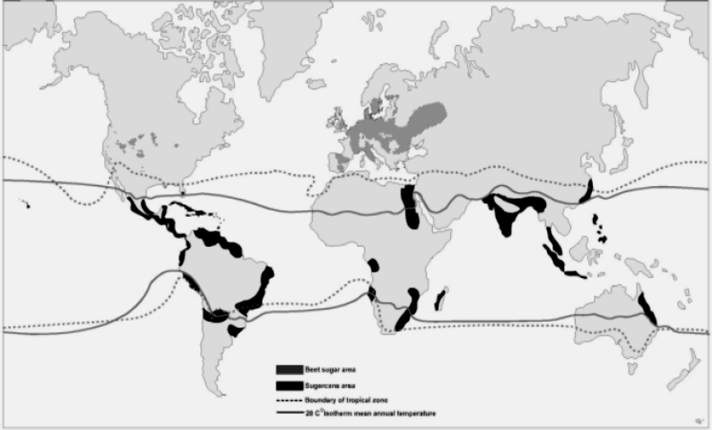
Figure 1. Sugarcane Growing Regions of the World.

- The overall objective of the SUCRE project is to catalyze the establishment of a commercial market for sugarcane-based electricity supply to the Brazilian grid, to displace fossil-fuel electricity that would otherwise need to be generated to meet growing electricity demands in Brazil. GEF has helped lay the foundation for a cane-power industry in Brazil by sponsoring an earlier project (“Biomass Power Generation”) that was largely a technology development and capacity building effort []. The SUGARCANE RENEWABLE ELECTRICITY (SUCRE) project will build on this earlier effort to catalyze the transformation of the sugarcane industry in Brazil into one for which supply to the grid of renewable electricity from sugarcane biomass becomes a significant and core aspect of the business, alongside sugar and ethanol production. To maximize the potential for electricity generation from sugarcane, the project will facilitate the expanded use of bagasse (the fiber from milling cane stalks that is already used to a significant extent for heat and power generation at sugarcane processing facilities) and launch the widespread use of sugarcane “trash” (the tops and leaves of the sugarcane plant that historically have been burned on the cane field as a waste product). As was determined in the “Biomass Power Generation” project, the quantity of trash that is available on a typical cane field at harvest time is equal to the amount of bagasse produced. Thus, considering trash and bagasse, the biomass resource from sugarcane is effectively double the resource commonly associated with sugarcane.

- Important positive environmental and social impacts will flow from the effective use of sugarcane trash under the market transformation that will be catalyzed by the SUCRE project. These are discussed in detail later in this document, but in summary the impacts include
- Reduced greenhouse gas (GHG) emissions (both by substitution of renewable electricity for fossil fuel generated electricity and by reduced emissions of methane from decomposition of trash that would otherwise be left on the field).
- Expansion of employment opportunities in harvesting, collecting and using trash for electricity.
- Intensified productive use of land devoted to sugarcane production due to production of significant electricity, in addition to sugar and ethanol.
- Reductions in local air pollution emissions by accelerating the shift from traditional burning of sugarcane trash to using trash for electricity generation.
- Increasing generation of electricity on a distributed basis, which contributes to decreasing grid line losses, helps avoid the need for new transmission lines, and improves grid stability.

Brazil’s Sugarcane Industry
- Sugarcane has been growing in Brazil for nearly five centuries. The first seedlings were brought from Africa to São Vicente (São Paulo state) in 1532 and taken to the state of Pernambuco in 1535, from where they began to spread all along the coast up to Bahia and down to Rio de Janeiro. With time Pernambuco and São Paulo became the two most important centers for sugarcane production. In recent history (~50 years) the state of São Paulo has taken the lead as Brazil’s most important sugarcane producing region.

- From Pernambuco the sugarcane spread to the states of Paraíba and Alagoas. In Southeastern Brazil, sugarcane expanded from São Paulo to Minas Gerais, Goiás, and beyond. Sugarcane is not cultivated in the Amazon forest, and most of the large expansion of sugarcane planting that is projected for the coming years will take place in areas far from the Amazon forest. Moreover, the Brazilian government announced in July 2007 that it will forbid the planting of sugarcane in the Amazon forest and will publish a zoning map detailing where sugarcane planting will not be allowed.

- Between 1994 and 2007 the production of sugarcane in Brazil grew from 241 million metric tonnes to 475 million metric tonnes [4]. In the 1994/1995 harvest 82% of the cane was produced in the S-SE-CW (South-Southeast-Center west) regions and 18% in the N-NE (North-Northeast) regions. At present the S-SE-CW regions account for 86% of production and the N-NE accounts for 14%.

- In the 2006/2007 harvest, about 47% (224 million tonnes) was used to produce sugar, 43% (206 million tonnes) to make ethanol, and 10% (or 45 million tonnes) was used to produce cachaça and for other uses. In the 2006/2007 harvest Brazil produced 30.2 million tonnes of sugar and 17.5 million cubic meters of ethanol [].

- One of the key reasons for Brazil’s leading international position in sugar and ethanol production is the high sustainable yields achieved in sugarcane production. Between 1975 and 2000, average annual sugarcane yields per hectare in Brazil increased by 33% as a result of breeding and agronomic innovations []. Yields have historically been higher in the S-SE-CW region than in the N-NE region, and this disparity persists today. In the 2005/2006 harvest the average yield in the S-SE-CW region was 78.8 t/ha/yr and in the N-NE region it was 52.6 t/ha/yr [4]. For the 2006/2007 season these figures increased to 81.8 t/ha/yr and 56.2 t/ha/yr.

- It is estimated that in 2007/2008, the total area planted with sugarcane was 6.6 million hectares, and the sugarcane harvest increased to 528 million tonnes [4]. The S-SE-CW region produced about 462 million tonnes (87%), with the largest portion (2/3 of this total) in the state of São Paulo. Of the total national production, 237 million tonnes (45%) was for ethanol production, 232 million tonnes (44%) for sugar, and 60 million tonnes (11%) for cachaça and other products.

- Sugarcane always has been among the most important Brazilian crops, and in 1975, as a response to the abrupt increase in world oil price the government launched the Pro-Alcohol program, the main purpose of which was to substitute imported petroleum fuels with domestically-produced ethanol.

- Consistent governmental support was provided to the Pro-Alcohol program in one form or another for 25 years, which helped establish the industry, helped it weather periods of low oil prices, and ultimately helped it reach its current status of producing ethanol more competitively (without subsidy) than anywhere else in the world (Figure 2). Brazilian ethanol competes head-on today with gasoline when oil prices are as low as about $30 per barrel (Figure 2 and Figure 3).

- The Pro-Alcohol program has changed the face of the sugarcane and automotive industries in Brazil, and now, 30+ years since the program was born, the introduction of flex fuel cars (which can use any mixture of gasoline and ethanol) has secured the industry an indefinite future in Brazil, and also provided a model for other countries to emulate.

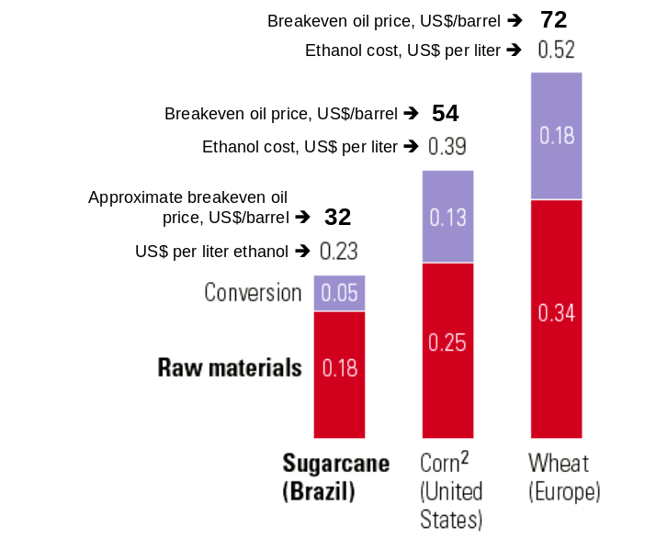
Figure 2. Comparison of Brazilian ethanol production costs with those in the United states and in europe
(excluding any subsidies and assuming current technology) []. The estimated corresponding breakeven world oil price is approximate and assumes a 20% engine efficiency advantage for a pure ethanol engine relative to gasoline [].

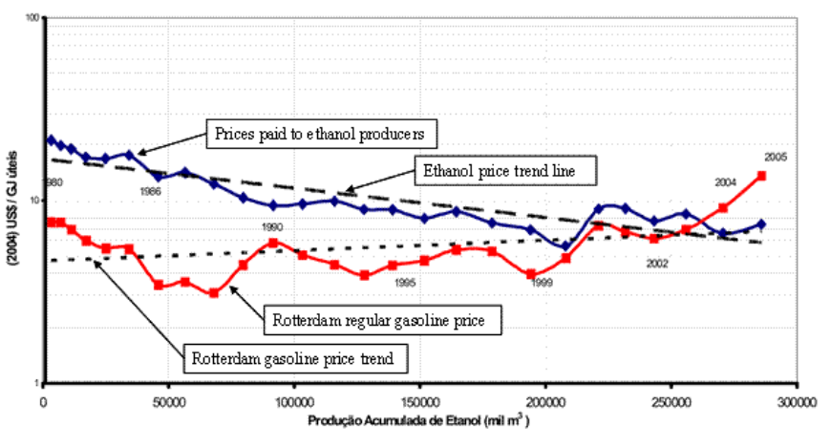
Figure 3. Historical cost reductions for ethanol in Brazil shown as a function of cumulative production[Error: Reference source not found].

- With successful establishment of a competitive cane-ethanol industry and the ramp up in oil prices during the past few years, the Brazilian sugarcane processing industry is undergoing a period of accelerated expansion. This presents an economic window of opportunity for the introduction of improved technology such as that which is the focus of the SUCRE project. Some 86 new sugarcane mills are expected to come online during 2010 to 2013 [Error: Reference source not found], nearly all of them in the S-SE-CW region. Cane production to supply the industry in 2013 may reach close to 730 million tonnes (but would represent the use of less than 4% of currently cultivated cropland and pasture in Brazil). Construction of an additional 61 sugarcane mills is under discussion, and these may come on line by 2020, when sugarcane production could reach one billion tonnes per year [Error: Reference source not found]. It is projected that up to 17 million hectares of land will be used for sugarcane by 2020, which would represent about 6% of Brazil’s current agricultural and pasture areas (and less than 20% of rain-fed land area that has been identified as suitable for sugarcane production) [Error: Reference source not found]. Figure 4 indicates that most of the projected expansion in cane production will be in the S-SE-CW region.

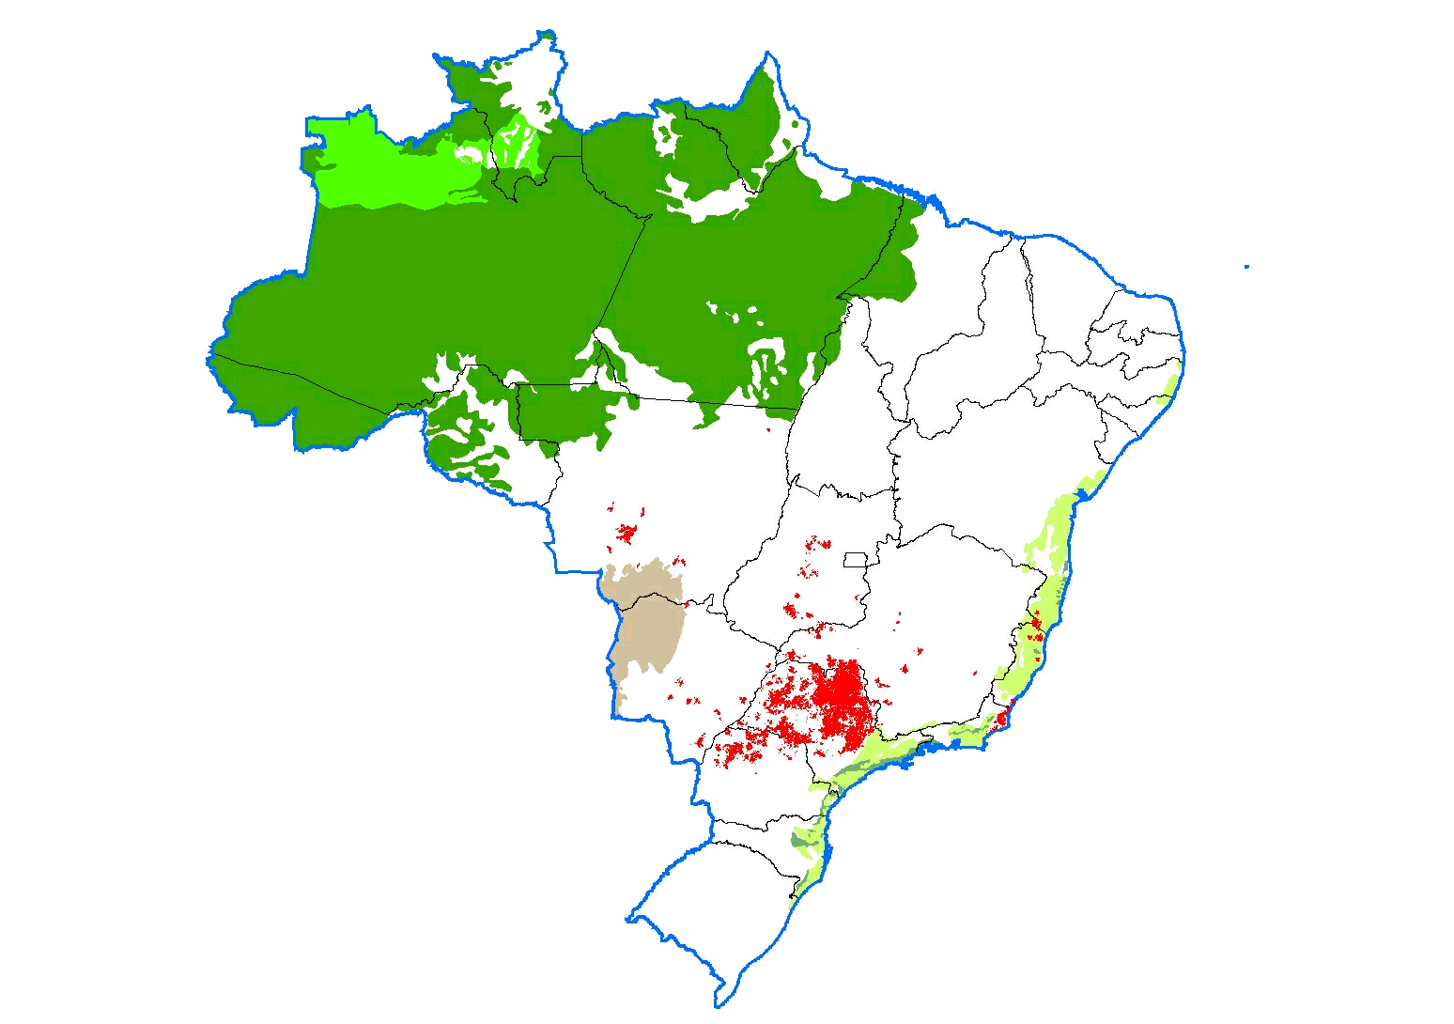
Amazon Forest
Primary existing and proposed new sugarcane
Pantanal grasslands
Atlantic Rainforest
Figure 4. Sugarcane growing area in brazil.

- Also, as the sugarcane sector continues its expansion, there is mounting public pressure to adopt green- cane harvesting systems to avoid the heavy local air pollution associated with traditional uncontrolled pre-harvest burning of cane fields. Green cane harvesting leaves large quantities of sugarcane trash blanketing the fields. If some fraction of this trash is not removed, methane (a powerful greenhouse gas) may be generated as the material decomposes.

- Green cane harvesting requires mechanized harvesting. Today, around 35% of the sugarcane in the Southeast region is green harvested by machine, and the fraction of mechanically harvested cane will be increasing in the future, in part as a result of a significant recent cooperation protocol signed in early June 2007 between UNICA (representing the sugarcane industry) and three branches of the São Paulo state government (Office of the Governor, Secretary of the Environment, and Secretary of Agriculture and Supply) with the aim of consolidating the sustainable development of sugarcane in São Paulo state.

- The protocol stipulates that the percentage of cane that will not be burned before harvest in areas where mechanized harvesting is possible (less than 12% grade) should increase from the expected 50% to 70% in 2010, and to 100% in 2014. The protocol also states that, if needed, the government will seek to promote developments to facilitate the utilization for productive purposes of sugarcane trash (the tops and leaves of the plant that traditionally would be burned off the field). The SUCRE project is in line with the general objectives of the São Paulo state government.

- As the sugarcane sector expands in the coming years, employment in the sector will increase. The sector already is a major employer in Brazil, presently being directly responsible for about 1.1 million jobs, or 2.3 jobs per thousand tonnes of cane processed annually. Total employment in the sector will increase substantially in the next few years with the implementation of the new projects mentioned earlier, even if the number of persons employed in the field per tonne of cane harvested is lower with mechanized harvesting of green cane than with manual harvesting of burned cane. The quality of the mechanized-harvesting jobs that are being created in the sugarcane sector are of much higher quality (and higher pay) than manual harvesting jobs offered in the past. Employment will be further increased if the SUCRE project is successful in catalyzing a market transformation in the sugarcane sector leading to widespread use of trash for electricity generation, because more workers will be needed for collecting and processing the larger amounts of biomass being used for electricity generation.

Energy Utilization of Sugarcane Bagasse and Trash
- Energy aspects of sugarcane processing are undergoing major transformations toward more efficient use and production of heat and power from sugarcane biomass. Old technology for steam and power generation, which is still in use in many processing facilities, is based on boilers delivering steam at 22 bar and 300°C. These systems are inefficient by design, such that they consume essentially all of the bagasse available at a mill while just meeting the process steam and electricity needs of the mill.

- Historically, when it was difficult to sell excess electricity profitably to the grid, this inefficient use of the bagasse avoided the need to dispose of excess bagasse. With growth in electricity demand in Brazil over the past couple of decades and the limitations in expansion of Brazil’s main electricity supply option of the past (hydroelectricity), electricity prices are rising, resulting in an increase in value for biomass-based electricity supplied to the grid.

- This is beginning to be recognized by sugarcane mill owners and is inducing more efficient steam and power generation at sugarcane processing facilities by use of higher-pressure boiler systems that offer the potential to generate excess electricity for sale to the grid. About 10% of facilities in Brazil export modest levels of electricity to the grid today. Most new facilities are being built with boilers operating at 67bar/490ºC, and a few are advancing to 100bar/520ºC steam conditions. Even some existing old installations (22bar/300ºC) are being changed over the 67bar/490ºC.

- Currently, there are some 2,300 MW of installed electricity generating capacity in sugar/ethanol mills, about 600 MW of which are sold to the grid during the harvest season. Table 1 highlights the substantially larger amount of export electricity that could be generated using higher pressure steam and power cogeneration technologies that are already well established commercially. The calculations in this table assume only the use of biomass that comes into a mill with green-harvested cane under today’s harvesting practices. This biomass includes bagasse, the fibrous portion of the cane stalk, plus 20% of the sugarcane trash available on the field. (This amount of trash is unavoidably entrained with the sugarcane when it is harvested and delivered to the mill.) Under these conditions, the potential amount of electricity available for exportation to the grid with the most commonly-used boiler pressure in Brazil today (22 bar) is small, typically 10 to 12 kWh per tonne of cane. Systems using higher boiler pressures are more efficient and so are able to generate more exportable electricity from the available bagasse while still meeting the mill’s steam and electricity needs. Table 1 shows the dramatic gains in export electricity production that are achievable.

Table 1. Sugarcane sector potential for exporting electricity at the 2006/2007 harvest level with utilization of sugarcane biomass available at a typical mill today (based on CTC data and calculations).
 |  | South-Southeast-Centerwest |  | Brazil
Technology | Export Elect Pot (kWh/t_{cane}) | Export Elect Pot  GWh/year | Installed MW (Export Pot) | Export Elec Pot  GWh/year | Installed MW Pot (exportable)
22 bar; 300ºC | 10 | 3,260 | 744 | 4,760 | 1,086
67 bar; 490ºC | 63 | 20,538 | 4,690 | 29,988 | 6,847
100 bar; 520ºC | 74 | 24,124 | 5,508 | 35,224 | 8,042
Note: Assumed cane production levels are 326 million tonnes in the S-SE-CW region and 475 million tonnes for all Brazil [4]. the sugarcane biomass available at a typical mill today is bagasse, the fibrous portion of the cane stalk, plus 20% of the sugarcane trash available on the field. This amount of trash is unavoidably entrained with the sugarcane during green cane harvesting.

- When utilization of more of the available sugarcane trash is considered, the power generation potential is even higher than in Table 1. (Also, the possibility of year-round power generation, rather than only during the 6-month cane crushing season, can be entertained. Year-round generation would make sugarcane power more valuable, since it could provide base load power demands.) Table 2 shows estimates of the exportable power generation potential in Brazil (with all onsite process steam and electricity needs in the sugarcane industry also satisfied) if all available bagasse and 100% of the trash were to be used as fuel. Estimates are given for the current cane harvest level and for the harvest level projected for 2020. Estimates are given for two boiler-based cogeneration systems (commercial technology) and an advanced (gasification-based) technology that could be in routine commercial use by 2020 [Error: Reference source not found]. Shown for comparison is the existing capacity of thermal power plants on the Brazilian national grid, as well as the capacity projected in official government forecasts for 2020. In 2020 the potential sugarcane power capacity with boiler-based cogeneration approximately equals the grid thermal capacity, and it is more than double the grid capacity with gasification-based cogeneration. It is thus conceivable that sugarcane power in Brazil could significantly reduce the need for grid-based thermal power generation, approximately 75% of which (both current and projected) is generated using fossil fuels.

- The SUCRE project aims to launch a commercial industry using bagasse and trash for electricity generation at sugarcane mills. Building on the results and experience gained in the GEF supported “Biomass Power Generation” project [Error: Reference source not found], the SUCRE project will aim initially to increase from 20% to 50% the amount of the available trash used to produce electricity for export from sugarcane mills. With this level of biomass utilization, the potential exportable power generating capacity is less than shown in Table 2, but nonetheless significant relative to current and projected levels of grid-based thermal power generating capacity (Table 3). In fact, because only about 10% of the sugarcane biomass that arrives at mills today with green-harvested cane is available as excess for generating exportable electricity, the increase in trash utilization from 20% to 50% leads to a very significant increase in the amount of exportable electricity generation at a sugarcane mill: electricity exports at a typical mill will increase by 60% to 70%, as can be seen by comparing the export electricity potential (kWh/t_{cane}) in Table 3 with the corresponding values shown in Table 1.

Table 2. Brazil sugarcane sector potential for export electricity with 100% trash and bagasse utilization.
 |  | MW Capacity, 2007/2008 |  | MW Capacity, 2020
Technology | Export Elec.^{a,e}  (kWh/t_{cane}) | Potential Cane Power^{b,c} | Grid Thermal Power^{f} | Potential Cane Power^{c,d} | Grid Thermal Power^{g}
67 bar; 490ºC | 179 | 12,693 | 22,543 | 24,040 | 26,800
100 bar; 520ºC | 194 | 13,757 | 22,543 | 26,054 | 26,800
BIG/GT | 410 | - | 22,543 | 55,063 | 26,800
(a) If all available cane trash (0.14 dry t/t_{cane}) and 100% of bagasse were utilized. (b) Sugarcane production estimated for the 2007/2008 cane harvest: 528 million tonnes. (c) Assuming a capacity factor of 85%. (d) assuming annual cane harvest of one billion tonnes in 2020 [Error: Reference source not found]. (e) Based on performance projections by CTC (File: EE exported per ton of cane, 02/07/2007). (f) Grid Thermal power 2007/2008: Source ANEEl; includes 2,007MW of nuclear power. (g) Grid thermal power 2020: Source EPE; Plano Nacional de Energia 2030; Includes 4,300MW of nuclear power.

Table 3. Brazil sugarcane industry potential for exporting electricity with utilization of 100% of available bagasse and 50% of available trash (representing conditions to be implanted in the SUCRE project).
 |  | MW Capacity, 2007/2008 |  | MW Capacity, 2020
Technology | Export Elec.^{a,e}  (kWh/t_{cane}) | Potential Cane Power^{b,c} | Grid Thermal Power^{f} | Potential Cane Power^{c,d} | Grid Thermal Power^{g}
67 bar; 490ºC | 108 | 7,658 | 22,543 | 14,504 | 26,800
100 bar; 520ºC | 118 | 8,367 | 22,543 | 15,847 | 26,800
BIG/GT | 210 | - | 22,543 | 28,203 | 26,800
(a) If 50% of available cane trash and 100% of available bagasse were utilized. (b) Sugarcane production estimated for the 2007/2008 cane harvest: 528 million tonnes. (c) Assuming a capacity factor of 85%. (d) assuming annual cane harvest of one billion tonnes in 2020 [Error: Reference source not found]. (e) Based on performance projections by CTC (File: EE exported per ton of cane, 02/07/2007). (f) Grid Thermal power 2007/2008: Source ANEEl; includes 2,007MW of nuclear power. (g) Grid thermal power 2020: Source EPE; Plano Nacional de Energia 2030; Includes 4,300MW of nuclear power.

The Electricity Market in Brazil
- The electricity plan prepared by EPE, the organization responsible for electric-sector planning in Brazil, covering the period from 2005 to 2015 indicates an expected expansion of demand from 47,583 MW_{av} to between 76,224 MW_{av} and 81,158 MW_{av}.t. Under these conditions there will be a strong opportunity for sugarcane processors to export significant amounts of electricity to the grid in the future.

- In EPE’s reference scenario, which considers an average growth of Brazil’s GNP of 4.2% per year during the whole period, the expansion would be 39,057 MW, of which 30,045MW (77%) would be supplied by new hydro power plants and 9,012 MW (23%) by thermal power plants. Due to the country’s good economic conditions, it is quite reasonable to expect that instead of 4.2%, the GNP grows at a rate of 5.1% per year, as considered in the most favorable scenario of EPE’s studies. In this case, the participation of thermal power would increase to 13,712 MW.

- Figure 5 shows the different generating resources used to supply electricity in Brazil in January 2006 and EPE’s reference scenario projection for 2015. It shows that biomass is practically nil in 2006 and increases to a still-low 1% in 2015. Figure 6 shows the percentages of thermal generation in 2006 by fuel type and how the mix is projected to evolve by 2015 in EPE’s reference scenario. Biomass will evolve from a participation of close to 0% in 2006, up to 7% in 2015.

- The increasing surplus of bagasse and trash (biomass) that will happen in the sugarcane industry, and the large amounts of energy required to supply the country’s demand for electricity in the next years makes clear the opportunity of making biomass a reliable fuel to be used to produce electricity for the Brazilian national system. In order to do that it will be of fundamental importance to increase the efficiency of using and producing electricity in the sugar mills, and also of collecting and using as much as possible the sugarcane trash produced by the mechanical harvesting that today is left in the field to rot.

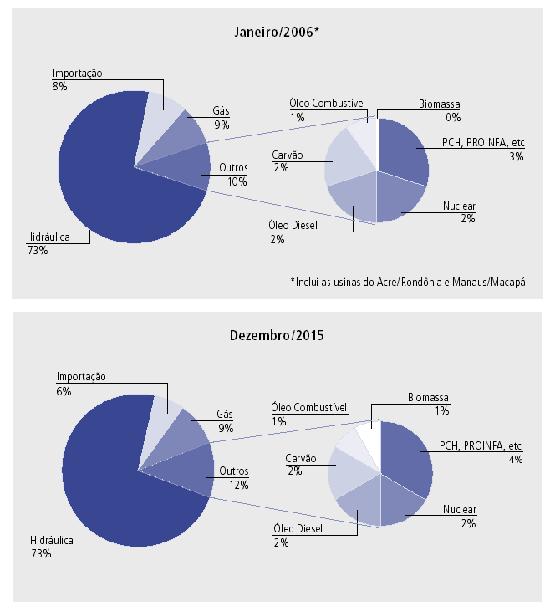
Figure 5. Current and projected electricity generation by source in Brazil [].

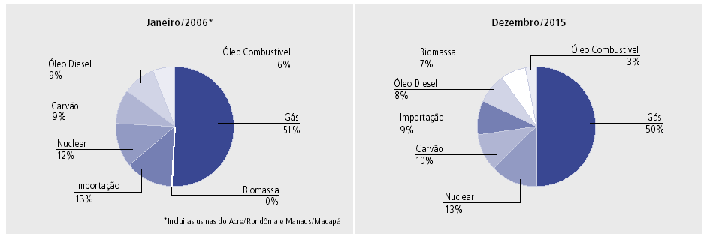
Figure 6. Current and projected thermal electricity generation by source in Brazil.

- There is an important complementarity between the potential availability of sugarcane electricity and the availability of hydroelectric power in the SE region, where the majority of Brazil’s electricity demand is concentrated and where the majority of Brazilian sugarcane is produced. Hydroelectricity supplies the majority of electricity demand, but hydro power availability has a seasonal character to it (Figure 7), with less available power during the dry period of the year. Coincidentally, the sugarcane harvesting season and associated potential electricity generating period at mills in this region during the dry period (May to November). Thus, electricity from sugarcane biomass has considerable value (in water savings) even if it is generated only during the cane crushing season.

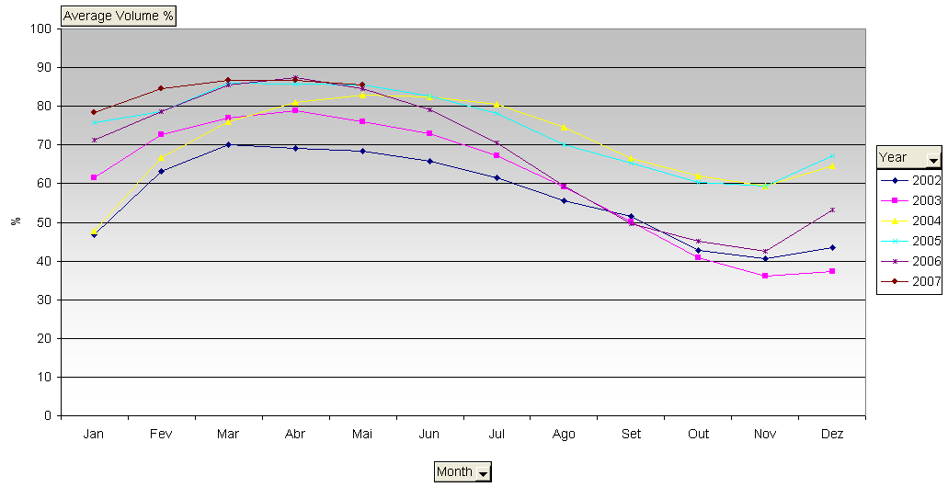
Figure 7. Average monthly volume of water in hydropower reservoirs in Southeast Brazil (percent of capacity).

- There is already a regulatory framework in place to help facilitate sale of electricity from sugarcane mills to the grid. An initial effort to encourage such sales was the 2002 Federal PROINFA program that provided for the compulsory acquisition by the grid of 3,300 MW of power from renewable sources, of which 1,100 MW was stipulated to come from biomass. The program established a ceiling price for each source of energy, and in the case of sugarcane cogeneration this price was below the market price for electric power, which discouraged participation. As a result, only 685 MW of biomass plants applied for PROINFA contracts.

- New electricity sector regulation passed by the Brazilian Congress in 2004 helped to remedy some of the problems under PROINFA. The new regulations have the following features:
- Firm production capacity of a power generator is calculated on the basis of the average energy production during the year. As a consequence, there is no longer “discrimination” by the grid against seasonal power generation by sugarcane mills. Brazil’s hydroelectric plants, which account for 85% of the country’s generation capacity, have large reservoirs and can modulate seasonal production.
- Electricity distribution companies (“discos”) can only contract energy from private generators via country-wide auctions carried out annually. Any generator may participate in these auctions, regardless of location. This allows power generators to seek out the best price of power sales, rather than being restricted to the local disco.
- Contracts won at auction are long-term (15 years) and fairly simple: the producers receive a fixed payment for their availability plus a compensation for the operating cost when they produce. These contracts are offered three or five years ahead of actual production, thus allowing time for the plant to be built after it wins the auction. This contracting scheme reduces investor risks and facilitates project financing.

- There have been several auctions for “existing” energy, and three auctions for “new” energy, with contracts awarded for more than 6,000 MW of capacity (totaling more than 53,000 GWh/year of EE generation). The first of these plants will start production during 2008.

Threats, root causes and barriers analysis
- The S-SE-CW region accounts for the majority of the cane grown in Brazil for sugar and alcohol production, as noted earlier, and it is the cane-growing region where mechanized harvesting of green cane is growing most rapidly, so the SUCRE project activities relating to installation of trash-to-electricity systems will be focused in this region. In the 2006/2007 season, the S-SE-CW region accounted for about 65% (326 mi tonnes) of the sugarcane produced for sugar or fuel ethanol in Brazil. At present 40% (130 million tonnes) of the sugarcane in this region is harvested green (without pre-burning), and 80% of the trash generated in green harvesting is left on the field. (The other 20% of the trash is unavoidably entrained with the green cane stalks delivered to the mills.)

- The SUCRE project aims to remove the barriers to utilizing more of the sugarcane trash for electricity generation at sugarcane mills. These can be characterized as technical and financial, information and awareness, and regulatory.

- The main reason for not collecting and using the trash that is available in the S-SE-CW regions is the absence of a commercially accepted technology for collecting, transporting, and processing the trash in the mills where it could be used to produce heat and power. So, the main reason for the present waste of energy and barrier preventing the additional use of biomass is technical. It is important to note that the technical barrier is not only related to harvesting additional amounts of trash. The inclusion of more trash in the bagasse fuel mix that powers the boilers requires fine adjustments that must be addressed in order to ensure the good performance of the generation system. For the widespread acceptance of sugarcane trash as a viable biomass fuel source, the generating system must be proven under various conditions present in different mills. This requires that all potential technical glitches be identified and addressed to reduce the risk of system inefficiency or malfunction.

- There is also insufficient information and awareness regarding the proposed technology. Several sugarcane mills already have seriously considered the use of trash. Nova America, Da Barra, Da Pedra, São Luis Dedini, São Martinho, Barra Grande, São José ZL, Quatá and São Francisco mills (all in the State of São Paulo) tried to recover trash to use as a supplementary boiler fuel, but without success. CTC, which will be the executing agency for the SUCRE project, supported these initiatives, providing information and technical help, based on the experience gained in Project “Biomass Power Generation”. However, most of the trials were restricted to tests in small areas and lasted only a few months, and in all cases the main reason for stopping was the lack of reliable information about the technology, equipment operation, and cost (investment, operation and maintenance costs). This illustrates the seriousness of the information barrier and the need for a larger scale intervention to demonstrate the commercial viability of the project.

- Not having a proven technology in place and the proper information regarding costs and investment requirements, makes it impossible to approach financial institutions like BNDES to secure the kind of financial support that is needed to modify the industry installations to handle trash. So, a third barrier that arises from the other two is the difficulty of getting the financial support necessary to commercially exploit trash. BNDES has demonstrated its technological sophistication in lending in the past, for example providing lower interest rates for loans on higher-efficiency boilers vs. lower-efficiency boilers, so the availability of proven technology and proper information will be effective in overcoming also the access-to-financing barrier.

- Unlike the situation in many countries, since the early 2000’s there exists a supportive regulatory framework in Brazil for private power generators, including sugarcane mills, to sell bagasse based electricity to the grid at profitable rates. Lately the, sugarcane mills have been gradually increasing their power generation as a response to the better prices paid for their electricity. However, electricity exports to the grid are still minor, with only 10% of mills participating in the electricity market. Furthermore, this process is occurring without full consideration of the different perspectives, problems and interests of the involved parties (sugarcane industry, commercialization companies, and government), mainly because the sugarcane mills do not have a good understanding of the electrical market and of its particularities. Therefore, the present rules of the electrical sector institutional model do not motivate the existing sugarcane mills to generate electricity, nor to use trash as a complementary fuel. This is slowly being modified to support the introduction of new power sources into the system. Some examples of remaining barriers that do not allow for a fully developed market for the sale of electricity from mills to the grid are presented below.
- One issue is how the rules for auctions treat “new” electricity. A new mill will only ramp up to full production capacity over several years, but would wish to begin selling electricity to the grid well before reaching full capacity. However, under the existing auction rules, any power generated in subsequent years after the first year will be counted as coming from an “existing plant” and not allowed to be sold via auctions for “new electricity” (which normally brings higher sale prices). To circumvent this restriction, sugar mills are dividing their power plants into two or three distinct units at the same site – a less efficient approach than a single unit – so as to be able to sell electricity at more lucrative prices. Given that the country needs all the power that can be produced at sugarcane mills, this rule creates unnecessary economic and energy inefficiencies.

- Specifically regarding the use of sugarcane trash, it is evident that the use of trash is costlier than bagasse since it does not have any other value to the mill other than as a fuel source. However, the present electricity price calculations does not consider this fact, taking the price of fuel as zero.

- An important problem is the long distance that must be covered by power lines from some mills to reach a grid connection point. This is a problem primarily with new, remote mills. Currently, such mills must bear the investment required to connect to the grid. In some cases the distances are huge and the added investment required for connecting makes it impossible for the mills to compete in auction. Such mills would, as a result, choose not to generate exported electricity. To overcome this problem EPE is studying the construction of connecting stations close to the areas where sugarcane production is expanding. EPE requires sound information about the sugarcane sector to make informed decisions regarding connection points in order to maximize the amount of biomass electricity supplied to the Brazilian grid in the future.

- An additional issue is that at present, the energy produced by the mills is paid on a monthly basis, without any regard to how much is produced daily or hourly. It would be beneficial to allow for contracts that consider different prices for electricity depending on the amount produced per day and per hour of the day.
- Power plants with capacities up to 30 MW only pay 50% of the “wire fee” (the fee paid to use the transmission lines). As most of the new mills have much higher power capacity and the trend is to increase even more, mainly with the use of trash, the scope of this restriction should be re-evaluated.

- The SUCRE project will address these barriers on multiple fronts. The initial throust will be focused on demonstrating the technical and financial viability of additional trash use in three mills. This will generate the technical, cost, investment, and environmental information required to prove the sustainability and commercial feasibility of the proposed solutions. Once the information is available an outreach effort will be undertaken to share the information with the whole sugarcane industry in Brazil and internationally. Besides that, it will be part of the scope of the project to begin the replication of the proposed solutions by supporting the analysis and planning work for installation in another seven mills.

- In parallel with the dissemination of the information about the use of trash to produce electricity, the proper material will be produced to facilitate approaching financial institutions like BNDES, to get the support required for the widespread use of trash for electricity production in the sugarcane industry. Work geared toward informing BNDES and other financial institutions will be undertaken as part of the outreach effort.

- The regulatory barriers will be addressed in the SUCRE project by working with UNICA (the organization that supports the sugarcane sector in legislative and regulatory discussions) in its interactions with government. The SUCRE project intends to conduct an in depth evaluation of the electricity regulation vi a vis the sugar sector, and propose possible regulatory modifications that would be mutually beneficial to the electricity sector and to the sugar mills. This will motivate the sugarcane industry to use trash to substantially increase electricity production, and provide additional information to the electricity regulator regarding the potential contribution of the sugar sector to national electricity production.

Institutional, sector and policy context
- CTC (Centro de Tecnologia Canavieira, or Sugarcane Technology Center), will be the executing agency for the SUCRE project. CTC is a non-profit association organized under the Brazilian law as an OSCIP that began in 1979 as COPERSUCAR Technology Center (Centro de Tecnologia COPERSUCAR), serving only the membership of COPERSUCAR, a co-operative of sugarcane processors in São Paulo state. In 2004, CTC changed its name to Centro de Tecnologia Canavieira and opened its membership to all sugarcane industry and growers in Brazil.

- Today, out of approximately 300 sugarcane processing facilities in Brazil, CTC has some 140 mills and distilleries as members, plus 17 sugarcane growers associations representing some 12,000 individual growers. Its membership was responsible in 2006 for the production and processing of 53% of the total Brazilian sugarcane production that year (Figure 8).

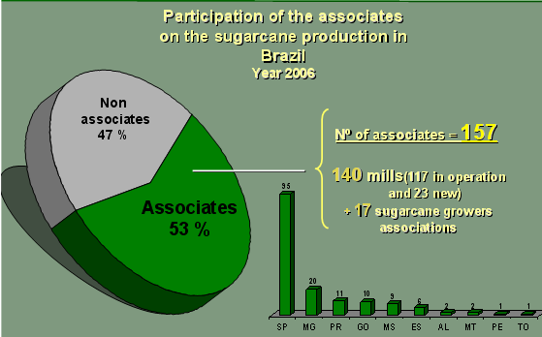
Figure 8. CTC membership and its contribution to total sugarcane production in Brazil in 2006.

- The Center has 320 employees, 106 with graduate degrees (MS or PhD), and experimental facilities in Piracicaba, Jaú, and Miracatú in the state of São Paulo, and Camamú in Bahia. Its main areas of work are sugarcane breeding; quality and decease control; cane production systems; and cane processing (including the heat and power utility systems present at every mill).

- CTC’s headquarters are located at the Piracicaba experimental facility, which comprises an area of 350 ha (Figure 9), and which houses CTC’s main research facilities. The work developed at CTC resulted in increases of +1% on the amount of sugar produced per hectare during the last 7 years, and +1% in the efficiency of cane conversion in the last 15 years. These gains have meant millions of dollars in additional income annually for the industry.

- Institutional and policy wise, the electrical sector legislation and the environmental issues are the most relevant aspects related with the success of the SUCRE project, the main aim of which is to help launch a commercial industry that uses trash in a sustainable way to increase the amount of electricity supplied by the sugarcane industry to the grid.

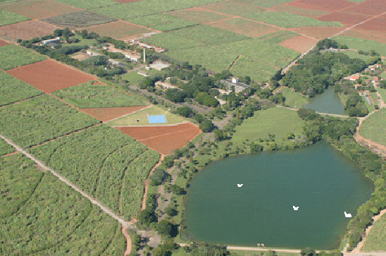
Figure 9. Aerial view of CTC’s Piracicaba experimental facility

- In Brazil, electricity can be provided from suppliers to users through one of two mechanisms. It can be sold outside the regulated electricity system, through direct contracts made between a customer and an IPP (independent power producer) or through an authorized agent. In these cases power is not typically provided on a base load basis, but rather on an “as-available” basis, which normally means lower prices and only short or medium term contracts. Alternatively, power can be provided, normally at higher prices, within the regulated system through the auctions promoted by CCEE. The auction system was discussed earlier in this document. This avenue for electricity supply usually results in long term and guaranteed contracts and thus would generally be preferred over the direct-sales-to-users approach.

- In addition to the norms that rule the electrical sector, the project will have to comply also with environmental legislation and guidelines. Normally the projects involving the construction of sugarcane mills are governed by environmental legislation prevailing in the state where the mill is located. It is envisioned that at least the first mill where trash use will be implemented will be in the state of São Paulo. As noted earlier, the state government is lending support to efforts to utilize trash as part of the effort to end the harvest burning of cane. Thus, environmental legislation and guidelines in the state are likely to be supportive of the project.

Stakeholder analysis
- As presently seen the key stakeholders and their interests in the SUCRE project are as follows:
- CTC will be the executing agency for the project. CTC’s knowledge base relating to trash collection and utilization for electricity export at sugar mills would be enhanced by the project. This will enable CTC to provide effective support for commercialization of trash use by sugarcane processors. CTC will be co-financing the project and has already invested heavily in preparation for the effort. After completing the earlier GEF-supported work relating to sugarcane biomass utilization (project “Biomass Power Generation”), as soon as CTC received an indication that GEF might consider supporting a new project to commercialize solutions identified in “Biomass Power Generation”, it began to invest to continue the development of the most promising solutions for collection, transport and cleaning of sugarcane trash (discussed below). This fact, besides showing CTC’s commitment to the idea of making trash a new fuel, also contributes to lowering the risks, funding and time required to implement the SUCRE project.
- UNICA works to promote new business opportunities for the sugarcane industries, including helping to addressing legal and institutional barriers. To assist UNICA’s efforts, CTC provides technical information and analysis on an ongoing basis.
- MCT/FINEP – government agency that supports development and demonstration of technologies to reduce and eliminate perceived risks so that a new competitive industry can develop and flourish in Brazil.
- Equipment manufacturers – these will benefit from technology development assistance and the creation of a new market for their commercial equipment.
- Sugarcane mills providing co-financing: the SUCRE project will help overcome risks of increasing electricity export to the grid using trash; profitability of the sugarcane sector should increase with successful projects.
- Other sugarcane mills: overcome risks of increasing electricity export to the grid using trash; increase profitability with successful projects, making viable a new energy feedstock for sugarcane processors (e.g., if ligno-cellulose conversion to ethanol is pursued, will need additional biomass).
- Sugarcane growers: they will benefit from larger revenues from supply of trash to mill. If the SUCRE project is successful, this would provide incentive for speeding up conversion to green cane harvesting.
- Electricity supply sector (utilities): increase biomass power supplied to grid to help avoid future shortages; reduced GHG emission associated with the grid.
- Federal, state and municipal governments: promote vitality of sugarcane industry, increase electricity supply to country, reduce greenhouse gas emissions, catalyze more green cane harvesting (less air pollution from burning), and promote regional employment and economic development.
- Financial institutions and banks: with successful project, techno-economic risk of trash utilization for export electricity production will be reduced, enabling routine lending for future projects.
- Industries/businesses related to the sugarcane and energy industries: future market for commercial equipment.
- Environmental entities and related institutions: the use of trash will contribute to decrease the amount of CO₂ that is thrown in the atmosphere, as it will substitute for fossil fuel and will also be an incentive to avoid pre-harvest burning of the cane.
- Carbon market entities and companies: a larger number of projects will be available for the CDM market.
- Agro research institutions like EMBRAPA, Polo National de Biocombustíveis and other research organizations: open new areas for research and development.

Baseline analysis
- This section describes the likely future situation if the SUCRE project does not happen. It provides the baseline for estimating changes that may be attributed to a successful project, including increases in biomass-electricity supplied to the grid, reductions in greenhouse gas emissions associated with electricity supply in Brazil, and costs for GHG emission reductions (“incremental costs”).

- At present a typical new sugarcane “mill” comprises a sugar mill and an annexed distillery, with a processing capacity of 2 million t_{cane}/yr, or 465 t_{cane}/hr, and bagasse boilers raising steam at 67 bar/490ºC (Figure 10). The boilers provide all needed process steam and generate electricity. After meeting onsite process electricity needs, the typical mill will have an excess of about 63 kWh/t_{n}for export to the grid (29 MW_{e}). Since green cane harvesting will be universally practiced in Brazil within a decade (at least in the S-SE-CW region), this harvesting method is considered the baseline for the project. The export electricity estimated for the typical new mill assumes green cane processing: the cane arrives at the mill entrained with 20% of the trash produced during harvest; this trash is crushed with the cane and considered with the bagasse utilized by the industry in the baseline situation.

- In the baseline situation, 80% of trash generated during harvest will be left on the field, due to the unavailability of technology, information, and financing for trash recovery and use. If there is no SUCRE project, this situation probably will continue, or will evolve only very slowly since no targeted program will be in place to foster further use of trash as a fuel source.

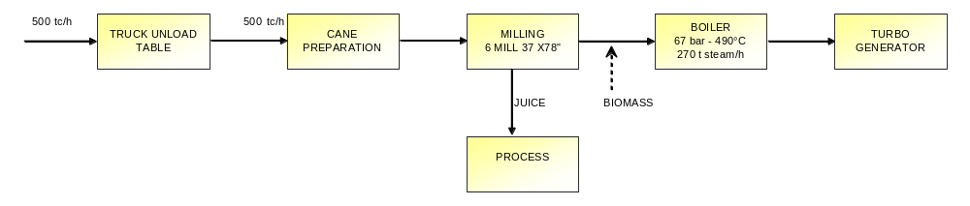
Figure 10. Baseline mill configuration. (The input of 500 tc/h includes 465 t_{cane} + 35 t_{trash} per hour.)

PART II: Strategy

Project Rationale and Policy Conformity

Project Rationale
- As indicated in the baseline analysis, if no action is taken the practice of leaving most of the trash on the field will continue for a long time to come. Besides that, due to the environmental problems caused by burning of the cane prior to harvest, the pressure for green harvesting is mounting, mainly in the state of São Paulo, where about 2/3 of Brazil’s sugar/ethanol industry is concentrated.

- An example of that is the already mentioned protocol, signed by UNICA and the Government of the state of São Paulo, on 4 June 2007, stipulating an advance in the dates by which phase-out of pre-harvest sugarcane burning would be stopped completely. In areas where mechanized harvesting is possible, the date was advanced from 2021 to 2014, and the parties agreed to reach by 2010 the percentage of unburned area of 70%. In areas with manual harvesting, the date was advanced from 2031 to 2017.

- Adding to the problems with leaving trash on the field is the projected steady expansion of Brazil’s sugarcane industry for the next 15 years. Around 90 new sugar mills will come on-stream in the next few years, and as demand for ethanol domestically and internationally grows, the most probable situation is that new mills will continue to be installed in Brazil beyond the ones already planned. The sugarcane industry has the full support of the Brazilian Federal Government, as well as most state governments where sugarcane is grown.

- All these factors point to a substantial increase in the quantity of trash that will be produced in the next years. Without new methods to productively utilize this trash, it will be left on the fields to decompose. The opportunity to use it for generating renewable electricity would be lost, and moreover it’s decomposition in the field may contribute to emissions of methane, a powerful greenhouse gas.

- The SUCRE project is intended to radically change this situation for the better by addressing technology, information-access, risk-perception, and financing-access barriers to commercialization of trash use for electricity generation. The project will demonstrate commercial feasibility and help launch a commercial industry for trash and bagasse – based electricity export to the grid. The project seeks to achieve practical and commercial results with the use of commonly-understood energy technologies and new (but not radical) agronomic and industrial practices and technologies, and thereby facilitating commercial replication by the private sector.

- The approach to technology in the SUCRE project will be to commercially implement systems for increasing trash collection during cane harvesting (Figure 11), for transporting and cleaning the trash at the mill (Figure 12), and for generating additional electricity to be exported to the grid. This will involve optimizing (to achieve lower costs, improved efficiency, lower GHG emissions) equipment developed in earlier work by CTC. Analysis undertaken as part of the preparation of this project (Annex 1) shows that the use of trash at a mill processing 465 t_{cane}/hr and using a 67 bar – 490ºC boiler will increase the surplus electricity available for export to the grid from 126,115 MWh/year (29 MW_{e} or 63 kWh/t_{cane}) in the baseline case (Figure 10) to 215,834 MWh/year (50 MW_{e} or 108 kWh/t_{cane}) in the SUCRE case (Figure 13). This represents an increase of about 70% in exportable electricity compared to the baseline.

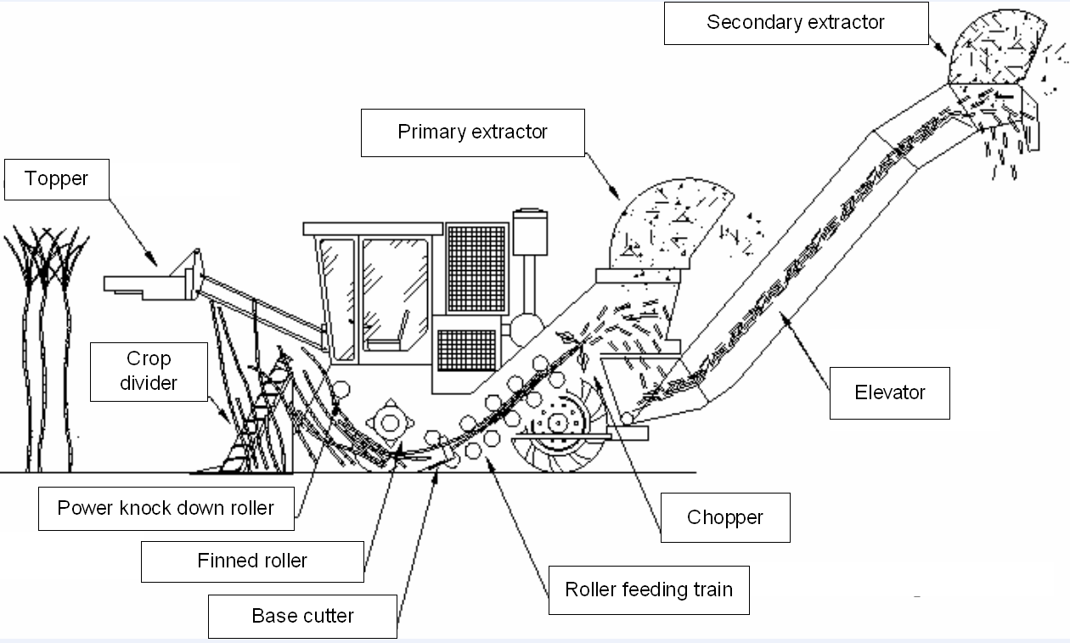
Figure 11. Green cane harvester for integrated trash recovery.
Existing cane harvesters operate the primary and secondary extractors at 850rpm, which maximizes the separation of trash from chopped cane during harvest – only 20% of the trash is entrained with the cane billets delivered to a mill. At 0rpm 100% of trash would be collected with the stalks. The SUCRE project will operate the extractor at 650rpm to collect about 50% of the trash with the stalks.
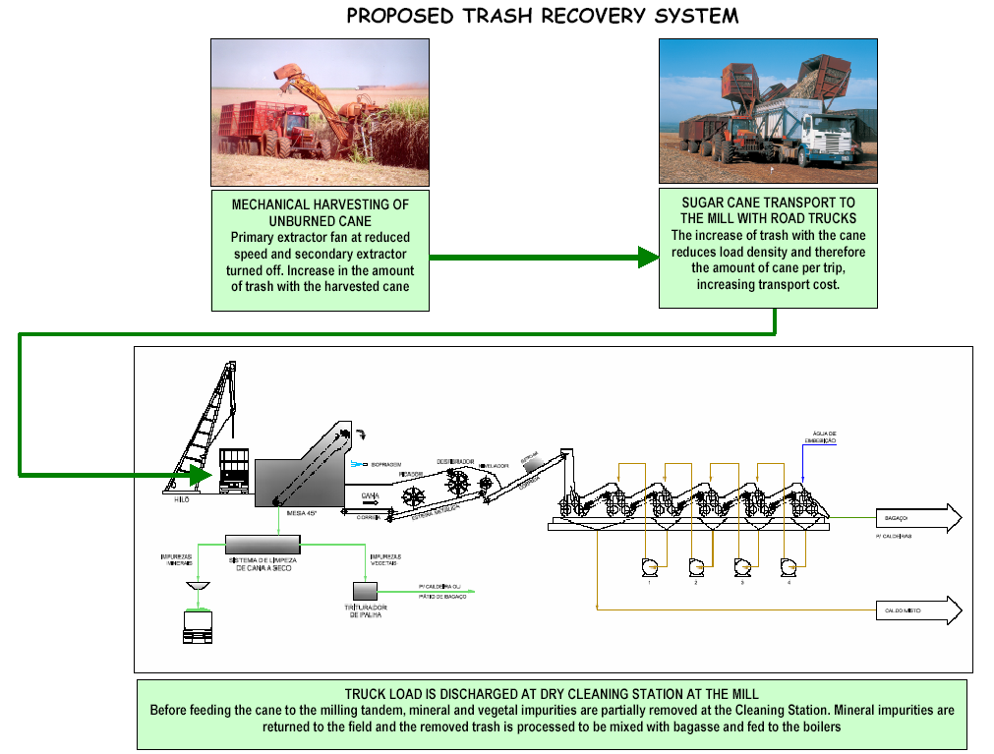
Figure 12. Trash recovery system proposed for the SUCRE project.

- The SUCRE Project will implement the trash utilization concept in three commercial sugarcane mills, as well as support feasibility studies for implementation at an additional seven mills. Implementation at a minimum of three mills is required in order to fully demonstrate the viability of trash utilization to the Brazilian industry. The first implementation, which will be used to work out “bugs” in the system, will be at an existing mill that uses a mix of chopped sugarcane and whole-stalk cane as feed to the mill. This mill is representative of the majority of existing mills in the S-SE-CW region of Brazil. The second mill at which the system will be implemented is one that is expanding its cane processing capacity by adding chopped-cane processing capability. The implementation of the trash system at this mill will be of interest for the many mills with capacity expansion plans. The final implementation will be at a newly-constructed mill, for which the trash utilization system can be designed in from the start. This implementation will be of interest for the large number of new mills that will be built as part of the expansion of the Brazilian sugarcane industry in the coming years.

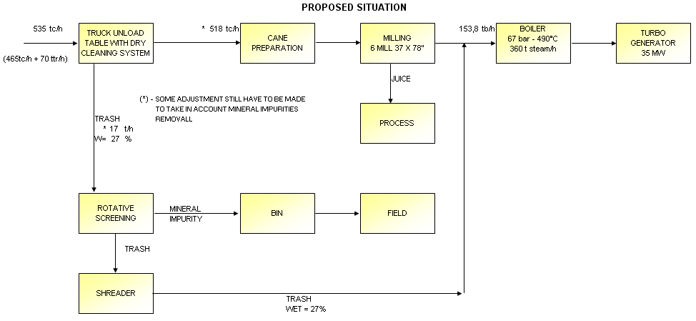
Figure 13. Representative process configuration to be implemented by the SUCRE project.

- Detailed economic analyses carried out in the preparation work for the SUCRE project (and based in part on cost assessments made in the prior GEF-sponsored project, “Biomass Power Generation”) have shown that an investment in trash collection and utilization by a mill, under typical mill financial assumptions and for electricity sale prices comparable to those awarded in recent auctions, would provide attractive returns. Moreover, the revenue to a typical sugarcane mill from sale of biomass-generated electricity would be in excess of 20% of the total revenues to the mill for alcohol, sugar, and electricity. At this level of revenue, electricity sales become a core revenue stream to the sugarcane mill alongside ethanol and sugar revenues.

- Together with the projected expansion of the sugarcane industries over the next 10 to 20 years, the grid-based fossil-fuel electricity generation that could be displaced by the added biomass-electricity output would produce substantial GHG emission reductions (see “Incremental Cost” section). It will also avoid some methane emissions that may occur when trash is left to decompose on the fields rather than being collected and used for energy. It will also contribute not only to creating new jobs, but also to improving the quality of jobs created, increasing incomes in rural areas where mills are located.

- Funding requested from GEF to overcome these barriers will directly leverage private-sector investments in excess of seven times the requested GEF funding. In the longer-term, the GEF seed funding will ultimately be leveraging hundreds of millions of dollars in new private-sector investments that will lead to significant quantities of renewable electricity supplied to the Brazilian grid, displacing the need for fossil-fuel electricity and the associated GHG emissions. The sugarcane mills have been investing substantially in recent years. In this particular case of “power generation with trash”, they are interested in investing on commercial equipment, once they have confidence on the technology and product that is going to be used, and also that they can get adequate prices for the electricity generated using the trash. The sugarcane industry is quite conservative, but there are some groups and individual mills that are interested in new technologies, but still are reluctant in investing in technology development. Therefore, GEF project and funds are of fundamental importance to motivate and gather Government, electrical sector entities, sugarcane producers, equipment manufacturers and research institutions aiming on adequately addressing the problems hindering commercial implementation of trash use to generate electricity at sugarcane mills and also motivating these players/stakeholders on co-financing the project. Without the synergic effect of GEF support, it is highly likely that delay in technology development, and in the establishment of an adequate regulatory scenario and market, might hinder the establishment of this important alternative to generate renewable energy. Just by mentioning GEF involvement and support, co-financing commitments already were obtained from three first mills, CTC and from manufactures, assuming that the GEF project will be approved.

- The GEF seed money will be used to support full implementation of the system in three mills, to leverage financing for investment in at least one additional mill, to support analysis for implementation planning in at least six more mills, to support discussions with government officials regarding regulatory changes in the electricity sector that would maximize biomass power supply, and to widely disseminate information regarding trash collection and utilization to help promote widespread commercial application of the concepts in Brazil and abroad. As already mentioned, the GEF participation in this phase of the SUCRE project is vital, since CTC and some mills (in and independent and non organized way) have been dealing with these barriers alone, and the only sound information available nowadays in the sugarcane industry is the product of a former GEF project conducted by CTC named BRA/96/G31 – Biomass power generation – sugarcane bagasse and trash. Despite the fact that a lot has already been done, there are still important aspects to be dealt with to reach the commercial readiness of the whole process, which involves several technologies. Time is getting critical, in the sense that trash has been a promise for some time now, and a real system (process & product) hasn’t reached the market, opening opportunities for other “non clean” technologies to substitute for biomass, as Brazil’s electricity demand continues to grow. The GEF project has leveraged substantial interest from all stakeholders, including the Government of Brazil and the sugar mills, all of which are investing resources into this initiative. This creates a unique circumstance where the level of interest and the volume of investment is sufficient to carry the technology from the pre-commercial to the commercial phase, addressing all of the remaining barriers preventing the widespread adoption of the technology. The participation of MCT with cash co-financing is particularly important since it demonstrates that it is of national interest to support this initiative.

Policy Conformity
- The implementation of the SUCRE project will: (i) contribute to transforming the nature of electricity generation in the sugarcane industry in Brazil; (ii) promote the utilization of a new renewable fuel; (iii) contribute to an expansion in the sustainable use of biomass for energy; (iv) introduce new technology to the sugarcane industry; and (v) lead to reduced greenhouse gas emissions from electricity supply in Brazil. The project is designed to promote increased sales of renewable energy to the grid by the sugarcane sector in Brazil, thus contributing to GEF Strategic Objective 4 (To Promote On-Grid Renewable Energy). Furthermore, the project will create the appropriate market conditions to promote investment in generation of electricity with bagasse and trash and therefore complies with Strategic Program 3 (Promoting Market Approaches for Renewable Energy). Given that the project will promote the use of biomass as a renewable energy resource, measures have been taken to ensure that the appropriate safeguards are in place for sustainable biomass use. Therefore, the project also complies with Strategic Program 4 (Promoting Sustainable Energy Production from Biomass).
- Privatization of a substantial part of the electrical sector in Brazil, the electricity shortage in 2001, and the electricity demand growth at an average pace of more than 5% per year in the last years set the conditions and was a great push for sugarcane mills start producing additional amounts of electricity to be exported to the grid.
The use of trash to produce electricity is being studied in Brazil since the beginning of the 90’s, and some progress has been made, but no commercial product was accomplished yet. If the present scenario of electricity demand continues, and no other electricity production alternative is established, without GEF support, eventually, a commercial system for using trash for power generation may come up by the end of the next decade, meaning that the space that could be occupied by biomass electricity probably already will be fulfilled by some fossil (mainly coal or gas) or nuclear power generation option. If that happens it is quite possible that the support from the Federal Government for renewable energy may vanish and biomass power generation disregarded in future scenarios. In this sense the GEF funding is of fundamental importance to avoid, or at least minimize, the increasing participation of non renewable energy sources in the Brazilian energy mix, and also to minimize construction of new fossil plants.

Detailed Project Description, Goal, Objective, Outcomes, Outputs, and Activities
- The overall goal of the SUCRE project is a significant increase in the supply to the grid of low greenhouse gas (GHG) electricity produced in the sugarcane industry. The objective of the SUCRE project is to create the conditions for sugar mills to increase the export of electricity generated by sugar cane trash and bagasse to the grid.

- Outcomes of the SUCRE project are designed to overcome the barriers to commercially-practiced collection and utilization of sugarcane trash for electricity generation and sales to the grid (Table 4).

Table 4. SUCRE project outcomes and barriers they address.
Outcome | Barrier
#1: Technology for sugarcane trash collection and conversion to exported electricity at sugarcane mills is commercially launched. | - Technology for sugarcane trash collection, transport, processing, and utilization for electricity generation in early development phase.  - Lack of demonstrated successful commercial implementation of sugarcane trash collection, transport, processing, and utilization for electricity generation at sugarcane mills.
#2: Economic and financial viability of sugarcane trash collection and utilization for export of electricity from sugarcane mills is commercially demonstrated. | - Financial viability of sugarcane trash collection, transport, processing, and utilization for electricity generation has not been tested in commercial sugar mill operations.  - Favorable financing conditions for sugarcane trash collection and use not available due to lack of knowledge and high risk perception.
#3: Environmental integrity of the use of biomass for energy is assured. | - Perception of use of biomass for energy as environmentally harmful  - Environmental impacts of sugarcane trash collection, transport, processing, and utilization for electricity generation not properly documented to date.
#4: Dissemination, capacity building, replication strategy across the sugar cane sector is under implementation. | - Insufficient technical and economic information available to potential mill investors considering implementing trash-to-electricity systems.  - Lack of leading technology adopters prevents investment. Most mills are conservative and will follow industry leaders only when the technology is demonstrated.  - Perception among potential investors and financing institutions of technical and financial risks of implementing trash-to-electricity systems.  - General lack of information delivered to relevant stakeholders regarding technical, environmental, and economic aspects of implementation of trash-to-electricity systems.
#5: Institutional, legal, regulatory framework is in place to promote the sustainable use of biomass for electricity generation and sales to the grid. | - Insufficient understanding in the sugar sector regarding contractual, regulatory, and legislative aspects of electricity sales.  - Existing electricity sector regulations and practices that discourage sugarcane mills connecting to the grid.

- In addition to the project outcomes described above, the project will also have a Project Management (PM) activity and a Monitoring and Evaluation (M&E) activity.

- The PM activity will encompass detailed project design and development and control of activities on a daily basis. The PM will be responsible for hiring staff and technical personnel and consultants, carrying out seminars and information sessions, including the inception meeting, coordination of bidding processes, contracting services and purchasing equipment, project monitoring and progress reporting, communicating with UNDP and other entities, disseminating project information, and supervising all project activities.

- The M&E activity will follow standard UNDP guidelines to track and evaluate progress, as described in detail in Annex 2.

- Table 5 describes the Outputs and Activities associated with each of the five project outcomes. To measure accomplishments, indicators and targets are defined for each of the outcomes, as listed in the Strategic Results Framework in Section II of this document. A more detailed project summary, including sub activities, is presented in Annex 5. The project costs are presented in Section III, total budget and Work Plan, and in more detail in Annex 4 of this document.

Table 5. Outcome, outputs, and activities.
SUCRE Project –
Outcomes: | Outputs: | Activities:
1. Technology for sugarcane trash collection and conversion to exported electricity at sugarcane mills is commercially launched. | 1.1. Trash collection and processing system ready for commercial implementation. | 1.1.1. Fine tune /optimize harvesting, collecting and transporting of trash
 |  | 1.1.2. Evaluate harvesting performance
 |  | 1.1.3. Fine tune /optimize separation, cleaning, storing, chopping and feed of trash
 |  | 1.1.4 Evaluate industrial equipment performance
 |  | 1.1.5. Estimate the impact of using trash on boilers, juice extraction and mill process
 |  | 1.1.6 Estimate energy generated by the system during season and year-round, and define industry equipment & configuration:
 | 1.2. Define the methodology to determine trash to be collected for specific mills (See Note 1 after the table) | 1.2.1. Define the methodology to estimate trash potential (based on varieties, areas controlled by the mill and the % of unburned cane)
 |  | 1.2.2. Define the methodology to estimate recoverable trash based on type of soil, slope and weed infestation
 |  | 1.2.3. Define trash availability integrating the two methodologies described above (trash potential and recoverable percentage) with type of harvesting (unburned/burned), using satellite images.
 | 1.3. System installed and operation evaluated in mill #1 | 1.3.1. Determine trash availability at mill #1
 | 1.3. System installed and operation evaluated in mill #1 | 1.3.2. Define trash recovery strategy, harvesting equipment specification, harvesting equipment configuration and quantity of each equipment for mill #1
 | 1.3. System installed and operation evaluated in mill #1 | 1.3.3. Basic implementation project for mill #1
 | 1.3. System installed and operation evaluated in mill #1 | 1.3.4. Follow up of trash system plant construction for mill #1; erection and commissioning
 | 1.4. Trash Collection and processing system optimized | 1.4.1 System performance evaluation
 | 1.4. Trash Collection and processing system optimized | 1.4.2. Definition of system modifications
 | 1.4. Trash Collection and processing system optimized | 1.4.3. Modification of trash system
2. Economic and financial viability of sugarcane trash collection and utilization for export of electricity from sugarcane mills is commercially demonstrated. (See Note 2 after the table) | 2.1. Economic analysis of trash collection and processing system | 2.1.1. Estimate additional investment, operation and maintenance cost
 |  | 2.1.2. Determine harvesting investment, operation and maintenance cost
 |  | 2.1.3. Determine industrial investment, operation and maintenance cost
 |  | 2.1.4. Determine agronomic costs related to trash recovery - benefits and problems (differential)
 | 2.2. Economic evaluation of year round electricity generation for mill #1 | 2..2.1. Collecting data on investment, operation and maintenance
 |  | 2.2.2. Economic evaluation for season operation
 |  | 2.2.3. Economic evaluation for year round operation
 | 2.3. Feasibility study for mill #1 | 2.3.1. Collecting data
 | 2.3. Feasibility study for mill #1 | 2.3.2. Perform feasibility study for mill #1
 | 2.4. Economic analysis of optimized trash collection and processing system– mills #2 and #3 | 2.4.1. Collecting data
 |  | 2.4.2. Economic analysis
 | 2.5. Feasibility study for mills #2 and #3 | 2.5.1. Collecting data related with mills #2 and #3
 | 2.5. Feasibility study for mills #2 and #3 | 2.5.2. Perform feasibility study for mills #2 and #3
 | 2.6. Supporting power sales negotiation for mils #1, #2, and #3 | 2.6.1. Support mills on the definition of energy sale price
 |  | 2.6.2. Support mills on the analysis of sale alternatives
 |  | 2.6.3. Technical support to mills on EE sale contract analysis
 | 2.7. Supporting securing financing and the development of business plans to mills #1, #2 & #3 | 2.7.1. Provide the technical support to secure financing to mills #1, #2, and #3
 |  | 2.7.2. Participate on the preparation of business plan for mills #1, #2, and #3
3. Environmental integrity of the use of biomass for energy is assured. | 3.1. Evaluate the ecological impacts (benefits/cost analysis) of trash utilization | 3.1.1. Physical, biological and anthropological impacts (air, land & water; vegetation & fauna; jobs & economy)
 |  | 3.1.2. Qualify and quantify the agronomic benefits
 | 3.2. Support mills #1, #2, and #3 to get the environmental licences (permits) required to install and operate the trash system | 3.2.1 Support the preparation of the studies required to get the environmental permits for mill #1
 |  | 3.2.2. Support the preparation of the studies required to get the environmental permits for mill #2
 |  | 3.2.3. Support the preparation of the studies required to get the environmental permits for mill #3
 | 3.3. Guidelines for environmentally acceptable implementation of trash utilization (collecting/processing) | 3.3.1. Evaluation of preventive and corrective measures related with the trash use
 |  | 3.3.2. Definition the basic parameters for monitoring trash system
 |  | 3.3.3. Preparation of guidelines
 | 3.4. Study of GHG reduction potential and issuing carbon reduction certificates linked with trash use (for typical mill) (See Note 3 after the table) | 3.4.1. Data collection
 |  | 3.4.2. Study of trash use GHG reduction potential
 |  | 3.4.3. Evaluation of carbon reduction certificate issuing potential linked to trash use
 | 3.5 Study on direct and indirect impacts of sugar cane expansion on land use | 3.5.1 Data collection on land use trends and projections due to sugar cane expansion
 |  | 3.5.2 Assessment of direct and indirect impacts of sugar cane sector on land use
 |  | 3.5.3 Design of a mitigation strategy to minimize negative direct and indirect environmental impact of sugar cane expansion
4. Dissemination, capacity building, replication strategy across the sugar cane sector is under implementation.. | 4.1. Guidelines for general pre-feasibility assessments of trash utilization | 4.1.1. Definition of methodology / criteria
 |  | 4.1.2. Preparation of guidelines
 |  | 4.1.3. Dissemination of guidelines
 | 4.2 Replication of first unit – System installed and operation evaluated for mills #2 and #3 | 4.2.1 Estimate trash availability and amount of trash to be recovered for mills #2 and #3
 |  | 4.2.2 Trash recovery strategy, harvesting equipment specification, harvesting equipment configuration and quality of each equipment for mills #2 and #3
 |  | 4.2.3 Basic implementation project for mills #2 and #3
 |  | 4.2.4 Follow up of trash system plant construction for mills #2 and #3; erection and commissioning
 | 4.3. Seven (7) mills feasibility studies of trash utilization and support for additional implementation through necessary basic engineering | 4.3.1. Selection of sugarcane mills
 |  | 4.3.2. Comduct feasibility studies in 7 additional mills
 | 4.4 Leverage investment for implementation of system in mill #4 | 4.4.1Select sugar mail on basis of financial commitment to project
 |  | 4.4.2 Begin implementation of trash processing system in mill #4
 | 4.5. Supporting future mill investors | 4.5.1. Promotion of stakeholders information workshops (technical, financial, regulatory, institutional, etc.) with the participation of international invitees
 | 4.5. Supporting future mill investors | 4.5.2. Creation of specific website
 | 4.5. Supporting future mill investors | 4.5.3. Issuing of a regular newsletter
 | 4.5. Supporting future mill investors | 4.5.4. Preparation and distribution of reports and guidelines with directions for participating in the EE market
 | 4.6. Monitoring the technical, economic, and environmental and other aspects related with the use of trash on the ongoing operation in mills #1, #2, and #3 | 4.6.1. Elaborate detailed plan for ongoing performance data collection
 |  | 4.6.2 Data collection and evaluation
5. Institutional, legal, regulatory framework is in place to promote the sustainable use of biomass for electricity generation and sales to the grid | 5.1. Detailed study of regulatory barriers and opportunities related with the participation in the EE market | 5.1.1. Study of the electrical sector legislation and EE sales contracts
 |  | 5.1.2. Study of regulatory opportunities and barriers, identifying options to overcome the identified barriers
 |  | 5.1.3 Technical support to institutional studies (aiming on overcoming barriers)
 | 5.2. Analytical support to stakeholders regarding institutional, regulatory, and legal aspects. | 5.2.1. Provide legal/regulatory advice to sugarcane industry investors regarding electricity sales to grid.
 |  | 5.2.2. Provide legal/regulatory advice to relevant stakeholders regarding contracting for trash supply. (related to Activity 1.2.4)
 | 5.3. Regulatory changes to facilitate trash-to-electricity discussed with relevant government entities. | 5.3.1. Analyze potential impact of alternative regulatory changes on industry-wide trash-to-electricity generation
 |  | 5.3.2. Interact with government in pursuit of regulatory changes that would facilitate greater trash-to-electricity implementation.
6 Project monitoring, learning, adaptive feedback, and evaluation | 6.1. Project monitoring and results evaluation | 6.1.1. Conduct project internal monitoring
 | 6.1. Project monitoring and results evaluation | 6.1.2 Conduct Mid Term and Final Evaluations
 | 6.2. Lessons learning and adaptive feedback | 6.2.1 Adjust project strategy according to feedback obtained during project implementation
7 Project management | 7.1 Project management | 7.1.1 Project management
Note 1: Item 1.2. Define the methodology to determine trash to be collected for specific mills comprises; (1) quantify the trash available in the field, which depends on the sugarcane variety, its age and the unburned harvested area; (2) define how much trash will be kept in the field for nutrition and soil protection; (3) accurately calculate the sucrose content of the mixture sugarcane + trash – see details in “Response to GEF Secretariat Review” Annex
Note 2: The task of determining whether the energy generation with trash is profitable has been considered in activities 2.2, 2.3, 2.4 and 2.5. A division of tasks has been made, considering data collection for the determination of costs and investments as “economic studies”. This was separated from the feasibility study, which incorporates taxes, investment return, energy price, market characteristics, alternatives for energy prices considering year round and season generation, sensitivity analysis, and different market strategies to sell the electricity generated such as: auctions, direct sales to big energy consumers, and sales in the spot market.
Note 3: The estimate of net GHG reductions related to trash use would be one of the steps towards the estimate of carbon reduction certificates, which would be a more complex task, that goes through all the processes required to provide the necessary basis for a documented bureaucratic process. Activity 3.4.3 takes the extra step of sector wide assessment of the costs and benefits of entering the CDM market, but does not support the development of specific CDM projects.

Project Indicators, Risks and Assumptions

Project Indicators
- The indicators and target results that will be utilized to measure project progress are included in the Strategic Results Framework in Section II of this document.

Risks

- The main risks associated with the project are as follows:

- Technical risks - The technology for trash recovery and use is not viable. This risk is considered minimal since the project executing agency (CTC), has conducted extensive testing in the field, under normal mill operations with the technology.

- Economic risks - Trash recovery and use is not economically viable. This risk is considered low as a result of the economic modeling that has been conducted by CTC, which demonstrates that at current electricity prices, generation with bagasse and trash is highly competitive with fossil fuel based generation. Furthermore, the diversification of the sugar cane industry to three products (sugar, ethanol, and electricity) is considered highly beneficial to the sector.

- Market factors make other (non trash-electricity) investments a higher priority to sugarcane mill owners – In this scenario, which is a more likely one than the previous two scenarios, the increasing demand for sugar and/or alcohol pull their prices to high levels, making it more interesting for sugarcane mill owners to invest in these areas. This is still only a moderate risk, because there is a very strong interest growing in biofuels, and the returns on investments in trash to electricity are likely to be quite favorable. The project includes efforts to optimize technology in order to maximize the return on trash to electricity, which will help mitigate this risk. However, if mill owners choose not to invest in trash to electricity, another option that could be pursued would be to look for third party investors interested in biomass electricity production.

- Delays due to slow environmental permitting pace – In this scenario, environmental licenses are not issued at the proper time, leading to delays in the SUCRE project schedule and, consequently, in the development of other future trash-to-electricity projects. This is considered a moderate risk. The involvement of the Federal Government (MCT) on the Project Steering Committee is designed in part to help deal with such situations if they arise. Also, should this scenario materialize, the project can appeal to the UNDP (which will also be on the Project Steering Committee) for help in speeding up the permitting process.

- Electricity prices fall – In this scenario, massive investment in new power plants, and decreases in fossil fuel (natural gas) prices result in huge new supply of thermal electricity, bringing prices to very low levels. This risk is also very small, as electricity demand has been increasing at higher pace than production for the past 10 years, and the trend in fossil fuel prices is upwards. Also, the pressure to substitute renewable energy for fossil fuel is mounting. If the unlikely happens and electricity prices fall, the sugarcane will have to look for ways of reducing its electricity production costs to ensure its competitiveness. The best assessments to date of the cost of electricity from sugarcane trash suggest that electricity prices would need to fall quite far before the competitiveness of sugarcane electricity is threatened.

- Financial collapse of the sugarcane sector – In this unlikely scenario, breakthrough technology brings new products to the market that substitute for sugar and alcohol (ethanol) at much lower prices causing a collapse of the Brazilian sugarcane sector. This risk is minimal or almost nil as sugarcane is considered today to be far and away the best feedstock for the production of sugar and alcohol, and new technologies are making the Brazilian sugarcane sector more and more competitive. For example, the relatively recent introduction of the flex fuel cars in the Brazilian market has been followed by the majority of new car sales being flex fuel cars. This helps ensure a strong market for Brazilian sugarcane ethanol. If the unlikely happens, there will be little that can be done to salvage the project.

- Environmental risks – The expansion of the sugarcane sector is deemed to have a negative environmental impact on land use in Brazil – As discussed extensively in this Project Document, the sugar cane sector actually represents a small proportion of agricultural and in Brazil, located far from the most vulnerable regions, such as the Amazon. Furthermore, the project promotes an increase in the energy yield per hectare, therefore not directly promoting the sector’s expansion. However, taking into consideration the ongoing worldwide debate regarding the use of biomass for energy production, the project will have a specific monitoring component dedicated to this issue. Furthermore, a targeted analysis of this issue will be conducted by this project to further clarify the potential direct and indirect links between sugar cane expansion and land use change in Brazil

- Soil fertility risk - Most of the sugarcane have been burned before harvesting and almost no trash is left in the field in the last 30 to 40 years. Recently part of the sugarcane has been harvested unburned, and a considerable amount of trash began to be left as a blanket on the soil. Leaving the trash on the field had different impacts. In some areas it has been beneficial, keeping soil humidity, controlling weeds and increasing soil fertility. In others, especially in cold areas, the trash has brought some plagues and difficulties for the soil cultivation. Regarding fertility, several studies conducted by CTC indicated that decomposition of organic matter, which makes available soil nutrients, is a quite slow process, and that the removal of part of the trash has no detrimental effect on the soil fertility and even on erosion control. The definition of these quantities for each type of soil and slope is part of the project scope. The SUCRE project deals with this issue in output 1.2. “Define the methodology to determine trash collected for specific mills”, and more specifically in activity 1.2.2. “Define methodology to estimate recoverable trash based on type of soil, slope and weed infestation”. Here all the aspects involved in leaving or removing the trash, using CTC past experience and information will be used to compose a methodology (systematic way) to define how much trash can be removed without prejudicing the soil. Additionally, Output 2.1. “Economic analysis of trash collection and processing system”, activity 2.1.4. “Determine agronomic costs related to trash recovery - benefits and problems (differential)” takes into account the impacts of leaving or removing part of the trash from the field in terms of sugarcane production.

- Climate change has a negative effect on trash to electricity – In this unlikely scenario, climate change due to greenhouse gas emissions leads to negative impacts, e.g., low sugarcane productivity due to changing rainfall patterns or other climate impacts. In the timeframe of this project, this risk is very low or nil, since global climate change appears to be occurring only slowly relative to the time scale of the project. If this scenario materializes, even lower sugarcane productivity is unlikely to have any significant negative impact on the project, since the percentage of available trash that is planned for recovery is only half of the available trash (under current productivity levels). A larger percentage could be collected, if needed to satisfy the fuel demands for electricity production.

Table 5 summarizes the main risks that the project will face and mitigation strategies.

Table 5. Risks that the project may face, and mitigation strategies.
Risk | Threat level to project success | Possible Mitigation Strategies
Technical | Low | - None
Economic | Low | - Strive to reduce production cost as much as possible to ensure competitiveness.
Financial collapse of the sugarcane sector | Low | - None needed
Electricity prices fall | Low | - Reduce production cost as much as possible to ensure competitiveness.
Market factors make other (non-trash-electricity) investments higher priority for sugarcane mill owners. | Moderate | - Maximize rate of return achievable with trash-to-electricity  - Pursue third party (energy-service company) investor/operator concept for trash-to-electricity systems
Climate change has negative effect on trash-to-electricity system | Low | - None identified
Negative environmental impacts of sugar cane expansion | Low | - Assessment conducted prior to project initiation, constant monitoring and research on this issue throughout project execution.
Delays due to slow environmental permitting pace | Moderate | - Government representation (MCT) on Project Steering Committee may help in speeding up the permitting process  - UNDP facilitation of permitting process

Assumptions
- Electricity prices follow current trends.
- Sugarcane sector continues to be economically viable.
- Harvesting of unburned cane continues to expand.

Expected global, national and local benefits
Global
- Reduced greenhouse gas emissions due to replacement of fossil-fuel generated electricity by sugarcane renewable electricity, as discussed in the “Incremental Reasoning” section.
- Dissemination of the results of a successful project outside of Brazil may lead to replication in other sugarcane growing countries.

National
- Establishment of Brazilian industries as leaders in manufacturing of sugarcane trash equipment. The SUCRE project will involve many, if not all, major manufacturers of relevant equipment, with the aim of transforming this manufacturing sector to serve the needs of the sugarcane sector in using trash for energy. Technology arising out of the SUCRE project will be able to be readily manufactured in Brazil, providing companies in the country with opportunities for domestic and export sales of commercial equipment. (Any technology developed using GEF funding will not be patent-protected.)
- Decreased reliance on fossil fuels for electricity generation.
- Improved use of hydro-electric resources as a result of larger contribution of biomass-electricity to the thermal generation mix.
- Increase of distributed generation of electricity (decreasing grid line losses, avoiding need for new transmission lines, improving grid stability).
- Economic benefits for sugarcane sector.

Local
- Increased employment associated with trash recovery and utilization
- Acceleration in the phase out of field-burning of trash (and associated local air pollution)

Incremental Reasoning
Description of the Baseline
- The Baseline (business-as-usual, BAU) scenario, i.e., in the absence of implementation of this project, is a situation in which most of the Brazilian sugarcane mill operations (for sugar and for ethanol production) phase in over time new 67bar pressure boilers and steam turbine systems utilizing bagasse available from crushing of green-harvested sugarcane stalks.

- Green cane harvesting generates large quantities of sugarcane trash (tops and leaves), 80% of which are left on the field to decompose in the BAU scenario. About 20% of the trash is unavoidably entrained with the sugarcane stalks and ends up in the mill as part of the “bagasse” burned in the boilers. The 67bar boiler pressure leads to more efficient steam generation than in the traditional 22bar boiler systems that are still found in many of Brazil’s sugarcane mills. The more efficient steam generation enables a larger amount of electricity to be generated for export to the grid, after the mill’s onsite steam and electricity needs are met.

- The trend to higher-pressure boilers and export of electricity is being driven today primarily by growing demand for thermally-generated power to complement and enable optimizing of the use of the hydro-electric facilities that provide the majority of Brazil’s electric power. Government regulations are supportive of new thermal generation, including from renewable sources. The trend to green cane harvesting is being driven by regulations banning the pre-harvest burning of cane to eliminate local air pollution problems. All pre-harvest burning of sugarcane (at least in the S-SE-CW region where the majority of Brazil’s cane is produced) will be prohibited by law within the next 10-20 years.

- The large amount of sugarcane trash left on the field after harvest represents a lost opportunity for using this biomass to generate additional electricity for export to the grid, where it could displace electricity that would otherwise have come from fossil fuel power plants (natural gas combined cycle or pulverized coal steam plants) and thereby reduce electric-sector GHG emissions. Moreover, leaving heavy blankets of trash on the field may lead to the generation of methane, a powerful greenhouse gas, in the lower layers (where oxygen is not available to oxidize the carbon in the biomass to CO₂).

- The project seeks to capture the global benefits that would derive from collecting additional amounts of trash from the field for use in electricity generation at sugarcane processing facilities. The electricity would be exported to the grid, where it would displace fossil-fuel electricity generation, reducing GHG emissions. Removal of additional trash from the fields may reduce methane generation levels, which would further reduce GHG emissions.

- There are four primary reasons that trash would not be collected under BAU: 1) absence of a commercially accepted technology to collect, transport, and use the trash for energy in mills, 2) a lack of reliable information about how to make profitable use of the available trash, which increases mill owners’ perceived risk of investing in such systems, 3) a perception that electricity generation is a “minor” activity for the mills, thus receiving less attention and investment than sugar or ethanol, and 4) the difficulty of accessing financing for a “risky” technology. (Unlike the case in many sugarcane-growing countries, the sale of privately-generated electricity to the grid is a barrier that has largely already been overcome in Brazil.)

- The project is designed to overcome all of these barriers, such that by the end of a successful project, there will be commercial implementations of trash collection, transport, and use systems at a minimum of three private-sector mills, with an additional seven mills having carried out implementation feasibility studies.

- Implementation of trash use at the three-to-ten mills directly participating in the project will lead to quantifiable GHG emissions reductions. The project as a whole, which includes outreach efforts to all relevant actors (in sugarcane sector, in electricity sector, in financing sector, etc.) is designed to catalyze the industry-wide pursuit of trash utilization for energy such that the successes in reducing GHG emissions at the initial few mills will leverage much larger GHG emission reductions in the long run. The GEF involvement has already been essential in committing additional stakeholders to the initiative and has fostered the creation of a unique partnership between the Government, the mills, and CTC that considerably strengthens the project.

- A quantitative estimate of the GHG emissions savings follows here, along with an estimate of the cost that GEF will be bearing per unit of GHG emission avoided. Detailed engineering analysis by engineers at CTC, together with a careful and detailed study of GHG emissions in the Brazilian sugarcane sector [] and other documents, provide the basis for these estimates.

Baseline GHG Emissions
- In the BAU scenario (baseline), sugarcane processing facilities export some electricity that is assumed to displace electricity that would otherwise have been generated on the grid using a mix of natural gas combined cycle and pulverized coal steam power plants. These avoided emissions are offset to some degree by emissions of GHGs associated with production and processing of sugarcane, such as diesel fuel burned by transport trucks.

- The net reduction of GHG emissions associated with electricity production achieved in the BAU scenario is an estimated 29.1 kgCO_{2equivalent} per metric tonne of cane crushed (29.1 kgCO_{2equiv}/TC) (Table 6). This figure does not consider emissions of GHGs from decomposition of trash left on the field after harvest. These emissions are not known with any certainty. (One project activity will be to quantify these emissions.)

- However, the potential significance of these emissions can be assessed with some “what-if” calculations, as follows. The primary emission from anaerobic decomposition of organic material is methane (CH₄). If it is assumed that 1% of the carbon in the trash left on the field after harvest in the BAU scenario is converted to CH₄, net GHG emissions reductions in the baseline case decrease to 12 kgCO_{2equiv}/TC (Table 6), or nearly a 60% decrease in the amount of GHGs avoided compared to the Baseline case without trash decomposition considered.

Table 6. Comparison of CO₂-equivalent greenhouse gas (GHG) emissions associated with electricity production at sugarcane mills.
 | Baseline | With SUCRE | Difference
Electricity generating capacity available for export to the grid (MW) | 29 | 50 | 21
Exported Electricity, kWh/TC | 63 | 108 | 45
GHG emissions (kgCO_{2equiv}/TC)
Without emissions from trash decomposition considered
Bagasse/trash production and processing | 8.8 | 9.95 | 1.2 (13%)
Grid Electricity Displaced | - 37.9 | - 65.0 | - 27.1 (72%)
Net emissions | - 29.1 | - 55.1 | - 25.9 (89%)
With emissions from trash decomposition considered (a)
Bagasse/trash production and processing | 8.8 | 9.95 | 1.2 (13%)
Trash decomposition on the field | 17.2 | 5.4 | - 11.8 (69%)
Grid Electricity Displaced | - 37.9 | - 65.0 | - 27.1 (72%)
Net emissions | - 12.0 | - 49.7 | - 37.7 (314%)
(a) Methane emissions associated with anaerobic decomposition in the trash blanket on a cane field are uncertain. The calculations in this table assume that in the Baseline case, 1% of the carbon in the trash left on the field is released as methane, which has 23 times the global warming potential of CO₂ on an equivalent weight basis. In the GEF case, since there is less trash left on the field (so that a greater fraction of the trash has access to oxygen), 0.5% of the carbon in the trash left on the field is assumed to be released as CH₄.

GHG Emissions with GEF’s SUCRE Project
- The scenario with the SUCRE project envisions that a total of 50% of the trash produced during harvest would be removed from the field (compared with the 20% removed in the Baseline case). The boiler system utilizing the trash operates at 67 bar, as in the Baseline case, but due to the larger amount of biomass fuel available, nearly twice as much exportable electricity is generated per tonne of cane crushed, resulting in nearly twice as much displacement of fossil-fuel generated grid electricity.

- Offsetting this larger amount of avoided emissions to a small degree is the additional consumption of fossil fuels used in collecting and transporting the trash to the mill. The overall net result is nearly double the emissions of GHGs avoided per tonne of cane crushed in the SUCRE case compared to the Baseline (55.1 vs. 29.1 kgCO_{2equiv}/TC). This is the result when trash decomposition is not included in the analysis. When decomposition is included (see Table 6 note), the avoided emissions per tonne of cane are over four times as large as in the Baseline case (Table 6).

- The SUCRE project includes implementation of trash collection and its utilization to generate electricity to the grid at a minimum of three mills and support for implementation at an additional seven mills, some of which may go forward with implementation. Thus, one may estimate the total GHG emissions reductions that will be directly a result of the project to be the emissions that would be avoided via trash recovery and utilization at a minimum of three mills and a maximum of ten mills.

- It is important to mention that the trash that will be recovered from the fields will not be related to all cane processed by the specific sugarcane mill, as basically only the cane coming from areas owned or controlled by the mills will be collected with trash. The co-financing letters inform the mills’ total crushing capacity in the reference year. The cane bought from growers won’t be considered at the moment, as the payment criteria for cane with trash isn’t developed yet, and a considerable amount of that cane is still burnt before harvesting. The three mills estimated that an average of 2 million tons of cane with trash will be brought to each mill within the scope of the SUCRE project. This fact has implications on the energy produced by the mills. The analysis undertaken as part of the preparation of the SUCRE project (Annex 1 of the PRODOC) shows that the use of trash at a mill, with a 67 bar – 490ºC boiler, that crushes 465 t cane/hr, will increase its electricity surplus, available for exporting to the grid, from 126,115 MWh/year (29 MWe or 63 kWh/t_{cane}) in the baseline case to 215,834 MWh/year (50 MWe or 108 kWh/t_{cane}) (Figure 13), which represents an increase of about 70% (45kwH/t_{cane}). The additional energy generation with the SUCRE scheme, considering that all the cane brought to a mill of 2 million tons per year is brought with additional trash (50% of all the trash available in the field) would be 215,834 MWh/year minus 126,115 MWh/year, corresponding to 89,719 MWh/year. The SUCRE project conservatively estimates that 60,000 MWh/year of additional energy will be produced by each of the three mills.

- The typical mill will process 2 million tonnes of sugarcane per year, which leads to estimates of the minimum and maximum amount of GHG emission reductions shown in Table 7. Emissions reductions are about 50% greater when trash decomposition is assumed in the estimates compared to neglecting any impact of trash decomposition.

Table 7. CO₂-equivalent GHG emissions reductions directly attributed to the SUCRE project.
 | Minimum (3 mills) | Maximum (10 mills)
Annual sugarcane processed, TC/yr | 6.0 | 20.0
CO_{2equivalent} emissions reductions (without considering trash decomposition)
Million metric tonnes per year | 0.16 | 0.52
Million metric tonnes over investment lifetime (a) | 2.3 | 7.8
CO_{2equivalent} emissions reductions (with consideration of trash decomposition)
Million metric tonnes per year | 0.23 | 0.75
Million metric tonnes over investment lifetime (a) | 3.4 | 11.3
(a) Assuming a 15-year investment lifetime.

- The SUCRE project is intended to catalyze industry-wide adoption of trash utilization in the long run. If the project is successful in this regard, the annual GHG emission savings that could be indirectly attributed to the project by 2020, when Brazilian sugarcane production is projected to reach one billion tonnes per year, could be between 26 million tonnes CO_{2equiv} per year (excluding the impact of methane from trash decomposition) to 38 million tonnes CO_{2equiv} per year (including the impact of methane from trash decomposition).

Cost of GHG Emissions Avoided
- During preparation of the SUCRE project detailed estimates of the cost of trash collection and utilization at a mill were developed. Based on these estimates, the full cost of generating exportable electricity at a mill will be recovered by revenue from sale to the grid, as discussed earlier in this document. In the project, these costs are being borne by private-sector co-financing. However, GEF and the Brazilian government are co-financing the project in order to overcome the barriers to the industry routinely making the investments to enable trash recovery and utilization. Thus, the GEF and Brazilian government co-financing (US$8 million and US$3 million, respectively) are the additional costs involved to capture the global benefit of GHG emissions reductions that can be achieved by utilization of trash compared to the Baseline scenario. This incremental cost ranges from a low US$0.2/tCO_{2equiv} to a high of US$4.8/tCO_{2equiv} (Table 8).

Table 8. Cost of GHG emissions reductions directly attributed to the GEF project.
 | Minimum (3 mills) | Maximum (10 mills)
Annual sugarcane processed, TC/yr | 6.0 | 20.0
CO_{2equivalent} emissions reductions (without considering trash decomposition)
Million metric tonnes per year | 0.16 | 0.52
Million metric tonnes over investment lifetime (a) | 2.3 | 7.8
Cost of GHG emissions avoided, US$/tCO_{2equiv} | 4.7 | 1.4
CO_{2equivalent} emissions reductions (with consideration of trash decomposition)
Million metric tonnes per year | 0.23 | 0.75
Million metric tonnes over investment lifetime (a) | 3.4 | 11.3
Cost of GHG emissions avoided, US$/tCO_{2equiv} | 3.2 | 0.2
(a) Assuming a 15-year investment lifetime.

Summary of Direct and Indirect emission reductions, using GEF methodology

Direct Emission Reductions
- The implemented bagasse and trash systems in the first 3 mills participating in the SUCRE project are considered to have direct CO2 reduction impacts, since these activities will result in direct greenhouse gas emission reductions during the project’s implementation phase. For the purposes of the GEF emission reduction estimate, CO2 reductions resulting from the avoidance of methane emissions due to trash decomposition are not included in the calculation.

- As a result of these activities during the project implementation period of 5 years, direct greenhouse gas emission reductions totaling 2.3 million tonnes of CO2 equivalent will be achieved over the lifetime of the investments of 15 years. In the non-GEF case, these energy needs would be satisfied by a mix of natural gas combined cycle and pulverized coal steam power plants with an emission factor of 602 gCO_{2equivalent} per kWh.

Direct Post-project Emission Reductions
- The project does not include activities that would result in direct post-project greenhouse gas emission reductions.

Indirect Emission Reductions
- The indirect emission reduction potential for this project is calculated by assuming that the additional 7 mills that are incorporated into the project under Outcome 4 invest in the technology and generate additional electricity with trash and bagasse. This is a conservative estimate since the successful technological and economic demonstration of the additional use of trash for energy generation is likely to trigger a more widespread application of the technology across the sugar sector. Using the GEF bottom-up methodology, indirect emission reductions attributable to the project are an additional 5.5 million tonnes of CO2 equivalent.

- The above calculations do not include CDM considerations. None of the involved mills have developed CDM projects for additional electricity generation with trash at this time. Should the mills decide to pursue CDM revenues, the GEF involvement in the pre-investment support will be clearly outlined to ensure that double counting of trash or energy will not happen.

Country Ownership: Country Eligibility and Country Drivenness

Country Eligibility
- Brazil is eligible for GEF financing since it signed the UNFCCC on June 4th, 1992 which was ratified by Congress, in accordance with the National Constitution, by means of the Decree no.1 of February 28th, 1994. The Convention entered into force for Brazil on May 29th, 1994, 90 days after its ratification by the National Congress.

Country Drivenness
- The main factors motivating the implementation of the SUCRE project are the increasing demand for electricity in Brazil in the coming years. As discussed earlier, EPE planning indicates the possibility that in 2015 the demand for electricity may exceed 81 GW_{av}. In EPE’s reference scenario the installed capacity increases 39 GW by 2015, of which 9 GW are thermal power plants, with the possibility of reaching 13.7 GW. This level of demand for new thermal electricity far exceeds the maximum that could be supplied by the sugarcane industry, which ensures a market for any sugarcane power that would be implemented.

- Moreover, Brazil has been one of the main promoters of using renewable energy around the world, which coincides with the project objectives. The fact that the Federal Government and Brazil’s president himself has been promoting the expansion of the use of alcohol as a substitute for gasoline, and the fact that the success of the project, and its replication, will enhance the competitiveness of the sugar cane industry, is an important motivation for its implementation.

- The decrease of CO₂ emissions that will result from the substitution of fossil fuels, and the accelerated expansion of the sugarcane industry, implying a growing substitution potential, are other important motivators to push for the development of the project.

- Alongside these factors are the social benefits that will result from the increase in employment and income that will derive from the proposed solution to avoid the waste of a renewable fuel.

Sustainability
- The sustainability of using trash to produce electricity in the sugarcane industry is directly connected with the success of the SUCRE project. If successful it will have demonstrated the commercial (technical and economic) feasibility of using trash as a renewable fuel to produce EE, and the economic force will be the major factor supporting the sustainability of the proposed solution.

- Along with the economic factor, the environmental aspects, expressed in renewed legislation requiring the phasing out of sugarcane burns, will be another strong motivation for maintenance of green harvesting supporting the sustainability of using trash as fuel in sugar mills.

- Another important factor that will help to maintain the sustainability of using trash as fuel will be the commercial relationship established by the mills owners with their clients, based on the EE produced from trash. The stronger and more profitable the relationship, for both sides, the greater will be the interest in sustaining the trash operation in their industries.

- The social benefits derived from the trash operation also will be an important factor in maintaining sustainability. The higher the income generated in the process and larger the number of people involved with the trash process, the greater will be the support for its continuation over time.

- Information and transparency influence, for better or worse, the way the project will be perceived by the people and the community in which it will be implanted, and consequently the sustainability of its results. So, divulging the environmental, social, technical, and economic aspects of the project will be of great importance for the sustainability of its results. The establishment of a partnership with the community will be of fundamental importance for the long term sustainability of the project results.

Replication
- Basically the same factors that will support the sustainability of the project results will be the key factors for its replication.

- If, as expected, at the end of the project the use of trash to produce electricity is demonstrated to be commercially viable, the economic force may be the most powerful motivation to push for its replication. As well as the economic drive the environmental and social benefits also will favor the project replication. Availability and dissemination of information about the project, the technology used, and its results, through the participation and promotion of seminar, congresses and workshops, maintenance of a well structured website, regular distribution of newsletter, will help to secure the project replication.

- Another important factor to spread the project replication would be the fact that know-how regarding trash-to-electricity systems would become a routine aspect of CTC’s knowledge base and professional structure such that CTC could provide support to potential future investors in trash-to-electricity systems on a cost-for-services basis.

PART III: Management Arrangements

- The project will be carried out by CTC (Centro de Tecnologia Canavieira, or Sugarcane Technology Center), with UNDP as the GEF implementing agency. CTC will coordinate the project and designate a Technical Coordination Team (TCT) composed by a National project Director, the Assistant National Project Director, a Technical Manager, a Financial Manager, an Environmental Manager, a Legal Manager and a Dissemination Manager. The TCT will be responsible for overseeing the day-to-day implementation of Project activities. This includes the direct supervision of project activities sub-contracted to specialists and institutions, whenever applicable. The TCT is responsible for the project’s operational planning, supervision and administrative and financial management and the adaptive management of the Project based on inputs from the Project M&E plan.

- The National Project Director (NPD) will be responsible for overall project management, including supervising and controlling the activities of five team leaders each handling activities under one of the five project outcomes. The NPD will also maintain the formal link with the funding institutions, investing mills or investors, cane growers, utilities, NGOs, UNICA, governmental institutions, and the external public in general. He will also be responsible for preparing meetings of the Project Steering Committee (PSC), as well as for all monitoring and evaluation efforts. The NPD will be supported in his activities by the Assistant NPD.

- A Project Steering Committee (PSC) will be constituted to provide political and technical advice and guidance to the project through periodic meetings. Representation on the PSC will include CTC, UNDP, the investing mills, the Brazilian government (MCT), and the NPD. Government representation on the PSC (MCT) is designed to ensure that the project keeps abreast of and maintains consistency with current policies and evolving national strategies and priorities. The SC will meet annually to review project activities and analyze the process and results of implementation to guide execution of the remaining Project actions. It would also identify and monitor the adaptive measures to correct problems identifies during project implementation, and support the incorporation of experiences and lessons learned generated by the project into national public policy. Figure 14 summarizes the structure described above.

Project Steering Committee (PSC)
Representation: CTC, MCT, UNDP, UNICA, investing mills, NPD.

National Director (NPD)
Assistant NPD

Manager (Mgr-T)
(Technical)
Manager (Mgr-E/F)
(Economic/Financial)

Manager (Mgr-E)
(Environment)

Manager (Mgr-L/R)
(Legal/Regulatory)

UNDP
Manager (Mgr-D)
(Dissemination)

Figure 14. Proposed SUCRE project management structure.

PART IV: Monitoring and Evaluation Plan and Budget

- The SUCRE project will be subject to both internal and external monitoring and evaluation.

- Achievement of results will be monitored internally by evaluating actual results against pre-determined Project Performance Indicators . External monitoring and evaluation will be undertaken following standard UNDP guidelines and procedures (Annex 2).

- In order to fulfill its obligations and responsibilities, the PM will have its own and separated budget. As described in detail in Annex 2, the budget for all internal and external monitoring and evaluation is US$336,000.

PART V: Legal Context and Other Agreements

- This Project Document shall be the instrument referred to as such in Article I of the Standard Basic Assistance Agreement between the Government of Brazil and the United Nations Development Program, signed by the parties on 29 December 1964. The host country implementing agency shall, for the purpose of the Standard Basic Assistance Agreement, refer to the government co-operating agency described in that Agreement.

- The UNDP Resident Representative in Brasilia is authorized to effect in writing the following types of revision to this Project Document, provided that he/she has verified the agreement thereto by the UNDP-GEF Unit and is assured that the other signatories to the Project Document have no objection to the proposed changes:

- Revision of, or addition to, any of the annexes to the Project Document;
- Revisions which do not involve significant changes in the immediate objectives, outputs or activities of the project, but are caused by the rearrangement of the inputs already agreed to or by cost increases due to inflation;
- Mandatory annual revisions which re-phase the delivery of agreed project inputs or increased expert or other costs due to inflation or take into account agency expenditure flexibility; and
- Inclusion of additional annexes and attachments only as set out here in this Project Document

COST RECOVERY POLICY

- As per Determination and Decision of the UNDP’s Executive Board on the Cost Recovery Policy over Regular and Other Resource-funded projects, the GEF contribution is subject to UNDP’s cost recovery as follows:

- Direct Costs incurred in the provision of Implementation Support Services (ISS) by UNDP. These costs shall be unequivocally related to specific activities and transactional services clearly identified, charged as per standard service fees in practice. These costs are an integral part of the project’s budget and shall be included in the activities’ budget lines corresponding to the services rendered.

SECTION II: STRATEGIC RESULTS FRAMEWORK (SRF) AND GEF INCREMENT

Table 9. SRF or Logical framework matrix for the SUCRE project.

Project Strategy |  | Objectively Verifiable Indicators
Goal: Increase the production of low greenhouse gas (GHG) electricity in the sugarcane industry, by using the trash, produced during the harvesting of green cane, as a renewable fuel to generate EE |  | The implementation of the SUCRE project will provide a practical experience of using trash from green harvesting, to increase the production of EE in sugar mills and distilleries, making available to all interested parties the technical and financial information required for spreading the demonstrated solution, making an important contribution to substantially increase the production of biomass EE in sugarcane mills and distilleries, and decreasing the emissions of GHG throughout the sugarcane industry.
Strategy | Indicators | Baseline | Target | Sources of Verification | Risks and Assumptions
Objective of the Project:  To create the conditions for sugar mills to increase the export of electricity generated by sugar cane trash and bagasse to the grid. | Trash system implemented and operating | No mills or distilleries are using the trash produced by the green harvesting | Trash system successfully demonstrated in one mill by end of year 3  Trash system successfully operating in 3 mills by end of project | PSC meetings held every 12 months  - Progress reports issued every 6 months  - Physical field inspection | Risks:  - Difficulties in implementation of technical solutions  Assumptions:  - Mills maintain interest in investment as expressed in commitment letters  - Equipment and supplies are delivered on time
 | Increase in exports of biomass based electricity to the grid | Electricity exports by mills limited to excess generation from sugarcane bagasse; no additional generation using sugarcane trash in place | 70% increase in electricity exports from mills that implement the trash system  60,000 MWh/yr exported to the grid by mill 1 at end of yr 3  180,000 MWh/yr exported to the grid by mills 1, 2, and 3 at end of project | - Progress reports issued every 6 months  - Sugar mill end electricity utility data | Risks:  - Electricity output based on sugarcane trash generation is not as high as projected  Assumptions:  - Electricity market conditions encourage mills to increase sales to the grid.
 | Economic feasibility of increased generation with trash is demonstrated | Electricity sales are a limited operation in sugarcane mills | Increased revenues from additional electricity generation demonstrated in 3 mills  The share of revenues from electricity generation increases in proportion to sugar and ethanol in 3 mills | - Progress reports issued every 6 months  - Sugar mill financial data | Risks:  - Costs of increased generation outweigh additional income stream  - Fluctuations in electricity pricing affect the economic viability of increased generation  Assumptions:  - Actual costs of increased generation are within the expected theoretical costs  - PPAs are signed for electricity sales at an appropriate price  - Electricity market conditions encourage mills to increase sales to the grid.
 | Trash system replicated across the sugar sector | No mills or distilleries are using the trash produced by the green harvesting | Investment leveraged for installation of trash system in at least one additional mill by end of project  Trash system feasibility studies for 7 other mills | - Progress reports issued every 6 months  - Written commitment of investment by additional mist  - Feasibility studies | Risks:  - Demonstration in 3 initial mills insufficient to trigger sectorwide replication  Assumptions:  - Sugarcane sector remains healthy and is prepared to invest
 | Environmental and legal framework in place for electricity generation with bagasse | Environmental and regulatory conditions for increased generation with sugarcane trash not fully defined | Clear, streamlined environmental guidelines and procedures for generation with sugarcane trash  Well defined regulatory framework for generation with sugarcane trash | - Environmental regulations  - Electricity sector regulations  - Project progress report | Risks:  - Delays in clarification of environmental and electricity policies  - Discrepancies between regulator entities and sugarcane sector  Assumptions:  - Government support for the project  - Environmental and electric market adjustments required are suitable for the environment and electricity regulators
 | Iinformation disseminated on project results and the benefits of additional generation with sugarcane trash | Limited information available on potential benefits of sugarcane trash use for electricity generation | Clear guidelines, procedures, and demonstrated benefits of generation with sugarcane trash are published and widely disseminated across the sugarcane sector in Brazil and internationally. | - Progress reports issued every 6 months  - Published project documentation | Assumptions:  - Project generates positive results that encourage sector wide adoption of technology.
Outcome 1:  Technology for sugarcane trash collection and conversion to exported electricity at sugarcane mills is commercially launched. | Trash collection system design finalized and operational | - No methodology to define trash to be collected in place | - Methodology defined and being used | - Project progress reports  - Practical test | Risks:  - Not getting/agreeing on the proper methodology  Assumptions:  - Team in place on schedule
 | Trash collection system design finalized and operational | Conceptual design for trash collection system in place | Final design implemented and operational in mill #1 | - Project progress reports  - Physical inspection | Risks:  - Timely availability of equipment
 | Sale of additional 60,000 MWh/yr of electricity (from mill #1) after three years. | - No trash system installed | - Generation of electricity from trash at mill #1 | - Project progress reports  - Physical inspection | Risks:  - Not having the trash system available for installation  - Not getting the required permits  - Not solving the legal and institutional issues  Assumptions:  - Financial support available  - Suppliers deliver on time  - Team in place on schedule
Outcome 2:  Economic and financial viability of sugarcane trash collection and utilization for export of electricity from sugarcane mills is commercially demonstrated. | Economic feasibility is fully assessed prior to investment | Limited information on economic and financial viability in place, based on existing R&D | Full feasibility studies and business plans finalized for mills 1, 2, and 3 | - Feasibility studies for 3 mills  - Business plans for 3 mills | Assumptions:  - Feasibility studies and business plans result in favorable economic valuation of projects
 | Economic/financial performance of mills #1, #2, and #3 evaluated based on actual operating data and costs. | - No trash-electricity system available | - Economic feasibility demonstrated for use of trash to make exportable electricity at mills #1, #2, and #3. | - Study/report on trash-electricity economic analysis using collected actual data.  - Project progress reports | Risks:  - Costs of increased generation outweigh additional income stream  - Fluctuations in electricity pricing affect the economic viability of increased generation  Assumptions:  - Actual costs of increased generation are within the expected theoretical costs  - PPAs are signed for electricity sales at an appropriate price  - Electricity market conditions encourage mills to increase sales to the grid.
 |  | - Electricity exports from mills limited to excess energy generated with sugarcane bagasse without trash | - 70 % increase in sale of electricity at mills #1, #2, and #3 due to inclusion of additional sugarcane trash | - Electricity sales contract  - Physical verification  - Mill operating reports  - Project progress reports.
Outcome 3:  Environmental integrity of the use of biomass for energy is assured. | Guidelines for environmentally acceptable trash utilization completed and distributed | - No guidelines required as no trash system is in use | - Guidelines completed and in use | - Guidelines for trash utilization  - Project progress reports  - Seminars and newsletter | Risks:  - Delays in clarification of environmental policies  - Discrepancies between regulator entities and sugarcane sector  Assumptions:  - Government support for the project  - Environmental market adjustments required are suitable for the environment regulators
 | Reduction of net GHG emissions associated with additional electricity generation verified based on actual operating data from mills #1, #2, and #3. | - No GHG reductions because no trash system in place | - Quantitative understanding of potential net GHG reductions from use of trash for electricity generation. | - Trash use GHG potential report  - Project progress reports | Risks:  - Not getting the proper information  Assumptions:  - Trash system is implanted and operated successfully  - Required information is available on time
 |  | - No GHG reductions because no trash system in place | - Sector wide analysis of CDM potential for enhanced trash use. | - Project report  - Project progress reports | Risks:  - Not getting the proper information  Assumptions:  - Trash system is implanted and operated successfully  - Required information is available on time
 | Sugarcane expansion clearly demonstrated as having minimal impact on deforestation rates in Brazil | - Studies conducted to date do not link sugar sector to increased deforestation | - Specific assessment conducted to demonstrate the potential impacts on deforestation.  - Mitigation strategy developed and under implementation | - Project generated reports | Risks:  - Assessment reveals more impact on deforestation than currently assumed  Assumptions:  - Full information is available to conduct assessment.
 | Additional removal of trash for electricity generation demonstrated no have negligible detrimental impact on soil | Historical data suggests that additional trash removal does not impact soil quality | Project assessment conducted to further assess impact of trash removal on soil quality | - Project generated reports | Risks:  - Assessment reveals more impact on soil quality than currently assumed  Assumptions:  - Full information is available to conduct assessment.
Outcome 4:  Dissemination, capacity building, replication strategy across the sugar cane sector is under implementation. | Guidelines issued for general pre feasibility assessment in sugar mills | No existing guidelines or procedures in place | Clear, streamlined guidelines and procedures for assessing potential benefits of additional generation with sugarcane trash | - Project documentation | Assumptions:  Knowledge generated through implementation in 3 mills is sufficient to generate guidelines
 | Feasibility studies and basic engineering of 7 mills (beyond the first three) interested in installing the trash system completed. | - No pre-feasibility studies being made | - Guidelines for general pre-feasibility assessment of trash utilization  - Feasibility studies for 7 mills (beyond the first three) completed | - Specific pre-feasibility studies  - Project progress reports  - Convinced investors | Risks:  - Not getting the proper information  Assumptions:  - Trash system is implanted and operated successfully  - Required information is available on time
 | Sale of additional 120,000 MWh/yr (from mills #2, and #3) after five years | - No trash system installed | - Generation of electricity from trash at mill #2 and #3 | - Project progress reports  - Physical inspection | Risks:  - Not having the trash system available for installation  - Not getting the required permits  - Not solving the legal and institutional issues  Assumptions:  - Financial support available  - Suppliers deliver on time  - Team in place on schedule
 | Mill #4 invests in electricity generation with bagasse | Mill #4 not yet committed to project implementation | Funding is leveraged from mill #4 to implement generation of electricity with trash. | - Project progress reports | Risks:  - Investment in first three mills does not clearly demonstrate the economic benefits of investment in generation with sugar cane trash  Assumptions:  - Sugar sector remains financially healthy and is not adversely affected by external economic crisis
 | Expressions of interest (contracted studies, letters of interest, participation at seminars, phone inquiries, etc.) from companies in trash-electricity, indicating market transformation. | - No trash system in place in additional mills  - No investors interested | - Clear demonstration of interest by 7 additional mills in investing in additional electricity generation with trash | - Participant lists from seminars, emails and letters from interested investors, studies contracted, website visits  - Convinced investors  - Project progress reports | Risks:  - Quality of information dissemination is inadequate to gain interest of stakeholders  Assumptions:  - Information dissemination systems are effective
Outcome 5:  Institutional, legal, regulatory framework is in place to promote the sustainable use of biomass for electricity generation and sales to the grid. | Mutually beneficial regulations fostering increased electricity generation with sugarcane trash are implemented | - Current legislation favorable to IPP generation but does not consider technicalities of generation with bagasse | - Full knowledge of relevant legislation regulating the electricity sector in Brazil is obtained, including potential solutions to address remaining barriers for generation with trash | - Regulatory study report  - Project progress reports | Risks:  - Not getting the proper information  Assumptions:  - Required information is available on time
 |  |  | - Meetings conducted with relevant state entities to discuss new regulatory framework that addresses sugarcane industry trash-to-electricity issues and barriers  - Mutually beneficial regulatory reforms agreed between regulating entities and the sugar sector | - Minutes of meetings  - Project progress reports | Risks:  - No access to government officials.  Assumptions:  - Meetings are held.  - Electric market adjustments required are suitable for the environment and electricity regulators
Outcome 6:  Project monitoring, learning, adaptive feedback and evaluation | Internal monitoring is applied and adaptive feedback mechanisms are implemented | Internal monitoring procedure described in project document | Internal monitoring procedures implemented with at least two project reports generated per year | - Project progress reports | Risks  - Lessons learnt during project implementation require major strategy revision  Assumptions:  - Assumptions made during the project design process are valid, allowing for a project implementation that is aligned to the conditions presented in the project document  Note: Any major revisions to project outcomes and/or project objective will be consulted with the GEF Secretariat
 |  | Project document reflects current understanding of best project strategy | Project implementation strategy is strengthened by continuous integration of lessons learnt during implementation | - Project reports and amendment compilation
 | High quality external evaluations are conducted | No evaluations conducted | One Mid Term evaluation and One Final Evaluation conducted | Evaluation reports | N/A

. Coelho, S.,“Brazilian Sugarcane Ethanol: Lessons Learned,” Energy for Sustainable Development, X(2): 26-39, 2006.
. Macedo, I.C., Leal, M.R.L.V., and da Silva, J.E.A.R., 2004. “Assessment of Greenhouse Gas Emissions in the Production and Use of Fuel Ethanol in Brazil,” São Paulo State Secretariat of the Environment, São Paulo, Brazil, May, 37 pages.
These features are formalized in the legislation that rules the sale of electricity in Brazil, which is expressed in the Law 10848/2004, Decrees 5136/2004 and 5177/2004, and in ANEEL Resolution 109/2004.
Separate auctions are held for “new” and “existing” electricity. The auction prices for electricity generated at existing facilities (“existing” electricity) are generally lower than prices at auctions for electricity generated from a newly-built facility (“new” electricity).
It has been observed that during transportation of trash by truck, the trash settles to almost half of the loading volume, so adjustments will be made to achieve a system that will achieve denser packing during loading. Also, during cleaning and processing of trash at the mill, adjustments will be made to decrease the amount of mineral material that goes to the milling tandem, where it causes accelerated wearing of the milling equipment, decreases milling capacity, and may affect cane juice extraction efficiency and quality. In addition, it will be important to ensure that during trash combustion in the boilers there is no deposition of material (e.g., molten ash particles) on critical parts of the boiler, which can result in efficiency loss increased maintenance costs.
This economic analysis was based on a typical mill processing 2 million tonnes cane per year and operating with a 67 bar/480ºC boiler system. Also considered is a minimum internal rate of return of 12% on a 100% equity investment. The electricity sale price in the most recent Brazilian auction (June 2007) was capped at R$140 per MWh.
This calculation is for a typical mill processing 2 million tonnes of sugarcane (TC) per year, 60% of which is used for ethanol production and 40% of which is used primarily sugar production. The cane used for ethanol production yields 80 liters of ethanol per TC. The cane used for sugar production yields 120 kg of sugar plus 10 liters of ethanol per TC. The calculation also assumes mill-gate prices of ethanol and sugar equal to those prevailing in July 2007 (R$0.6/liter ethanol and R$0.5/kg sugar). Electricity production is assumed to be 108kWh/TC (Table 3) and the assumed sale price is R$140/kWh.
Companies that are likely to be participating directly in the SUCRE project include DEMUTH MÁQUINAS LTDA (grinder and conveyor manufacturer), CASE – NEW HOLLAND (harvester and agricultural equipment manufacturer), CAMECO – JOHN DEERE (harvester and agricultural equipment manufacturer), RANDON S.A. Implementos e Participações (wagon and road equipment manufacturer), HBA Indústria Comércio e Manutenção de Equipamentos Agrícolas (wagon, road, and agricultural equipment manufacturing and maintenance), and CALDEMA and HPB Equipamentos Industriais Ltda. (boiler manufacturers).
CTC is an institution focused on the development of technology for the sugarcane industry. Once the technology becomes a product, it is spread to the market through manufacturers that are licensed for this purpose. The criteria used to select manufacturers consider their past participation in product development, industrial capacity and integrity, among other parameters. The technology is then offered to the whole market, in most cases, with some advantages to CTC’s participants, such as the support to define benefits and how to use the technology. Normally there is an effort made by CTC to disseminate the technology among the members of CTC, and with time it is spread to the whole market.
Macedo, I.C., Leal, M.R.L.V., and da Silva, J.E.A.R., 2004. “Assessment of Greenhouse Gas Emissions in the Production and Use of Fuel Ethanol in Brazil,” São Paulo State Secretariat of the Environment, São Paulo, Brazil, May, 37 pages.
The mix is 73% NGCC and 27% coal, the mix of incremental thermal power projected for 2005-2030 by Tomalsquin, M., “Plano Nacional de Energia 2030,” powerpoint presentation, Empresas de Pesquisas Energetica, Brasilia, 2007. The lifecycle GHG emissions from this mix is an estimated 602 gCO_{2equivalent} per kWh generated.
The decision to apply to get carbon credits in the CDM market will be made individually by each sugar mill. The process is costly and time consuming, but there are companies that accept to work on a risk basis, being paid with a share of the results obtained by the client. The CDM rules require full disclosure of any grant or development assistance funding used in a project, preventing the possibility of double counting. For the SUCRE project, only the carbon emission reductions related with the energy generated with trash are being considered, preventing that any previous CDM project focusing on power generation with bagasse, from being double counted.
. Hassuani, S.J., Leal, M.R.L.V., and Macedo, I.C. (editors), Biomass Power Generation: Sugarcane Bagasse and Trash, UNDP and Copersucar Technology Center, Piracicaba, Brazil, 2005.
. CONAB – Companhia Nacional de Abastecimento.
. Macedo, I. C., “Etanol de Cana de Acucar no Brasil,” presentation at the Seminar on Technologies for Future Ethanol Production in Brazil, Instituto Tecnologia Promon, São Paulo, Brazil, 17 April 2007.
. Assis, V., Elstrodt, H-P., and Silva, C.F.C., “Positioning Brazil for Biofuels Success,” The McKinsey Quarterly, special edition on Shaping a New Agenda for Latin America, 2007.
. Wyman, C.E., Bain, R.L., Hinman, N.D., and Stevens, D.J., ‘Ethanol and Methanol from Cellulosic Biomass,” Renewable Energy Sources for Fuels and Electricity, Island Press, Washington, DC, 1993, pp. 865-923.
. EPE, “Plano Nacional de Geracao 2005-2015”

